**Parking Management System**

**By Alec Agnese & Rami El Khatib**

**Group 18**

**COP 5339-001**

**Project Design Specification**

**Github Link:** <https://github.com/rkhat/ood-project>

**Youtube Link:** <https://www.youtube.com/watch?v=HjzBQH6cnNE>

**Project Title:** Parking Management System

**Functional Specifications**

The parking management system is an application to manage the whole process of parking a customer’s vehicle in a parking lot or garage. This includes parking the vehicle as well as paying for the spot. Only the customer will interact with the application. The project is going to be a simple desktop application and will run on any desktop OS (Windows, Linux or Mac).

When the application begins, it shows two choices; Member or Register. If the customer selects Register, they can signup for a new account. Clicking Member will allow old customers to log in to their account. Once logged in, The member can add a vehicle, remove a vehicle, select a vehicle to park, checkout, or access settings. Selecting a vehicle to park allows them to select a spot (if available). In the settings menu, they can add credits, change their password or log out.

**Use Cases**

1. Add Credits (Member)
2. Log out (Member)
3. Login (Member)
4. Sign Up
5. Park (Member)
6. Add Vehicle (Member)
7. Remove Vehicle (Member)
8. Checkout (Member)
9. Change password (Member)

**Use Case 1:** Add Credits

1. User carries out **Log In**
2. User clicks “Settings”
3. System displays Settings menu
4. User clicks “Add Credits”
5. System displays Credit Amount menu
6. System displays pop-up confirmation message
7. User clicks “Confirm”
8. System displays Settings menu

**Use Case 2:** Log out

1. User carries out **Log In**
2. User clicks “Settings”
3. System displays Settings menu
4. User clicks “Log out”
5. System displays Login Menu menu

**Use Case 3:** Log In

1. User clicks “Member”
2. System displays Login form
3. User enters username and password
4. System verifies login information
5. System displays Main Menu

**Variation #1:** Invalid login

1. In step 3, user enters invalid username or password
2. System display pop-up message “Invalid Login”
3. User clicks “Ok”
4. Continue with step 2

**Use Case 4:** Sign Up

1. User clicks “Sign up”
2. System displays Sign-up Form
3. User enters username and password
4. System verifies username unique
5. System display pop-up message “Account Created Successfully”
6. User clicks “Ok”
7. System logs member in and displays Main Menu

**Variation #1:** Username taken

1. In step 3, user enters unavailable username
2. System displays pop-up message “Username taken”
3. User clicks “Ok”
4. Continue with step 2

**Use Case 5:** Park

1. User carries out **Log In**
2. User selects vehicle from list
3. System displays parking spot map
4. User selects parking spot
5. System displays pop-up confirmation message
6. User clicks “Confirm”
7. System displays Main Menu

**Variation #1:** No Spots Available

1. User carries out steps 1-2
2. System displays pop-up message “No Spots Available”
3. User clicks “Ok”
4. System displays Main Menu

**Use Case 6:** Add vehicle

1. User carries out **Log In**
2. User enters plate number and clicks “add”
3. System adds vehicle to list

**Use Case 7:** Remove Vehicle

1. User carries out **Log In**
2. User selects existing vehicle to remove
3. System removes the vehicle from list

**Use Case 8:** Check Out

1. User carries out **Log In**
2. User clicks “Checkout”
3. System verifies that member has credits
4. System display pop-up confirmation message
5. User clicks “Confirm”
6. System displays Main Menu

**Variation #1:** No credits

1. User carries out steps 1-2
2. System displays pop-up message “Insufficient credits”
3. User clicks “cancel”
4. System displays Main Menu

**Use Case 9:** Change password

1. User carries out **Log In**
2. User clicks “Settings”
3. System displays Settings menu
4. User clicks “Change Password”
5. System displays Change Password form
6. User enters old password once and new password twice
7. System changes password and displays Main Menu

**Variation #1:** Incorrect old password

1. In step 6, user enters invalid old password
2. System displays pop-up message “Invalid old password”
3. User clicks “Ok”
4. Continue with step 5

**Variation #2:** New password not matching

1. In step 6, user enters valid old password but non-matching new passwords
2. System displays pop-up message “New passwords don’t match”
3. User clicks “Ok”
4. Continue with step 5

**Class Diagram**

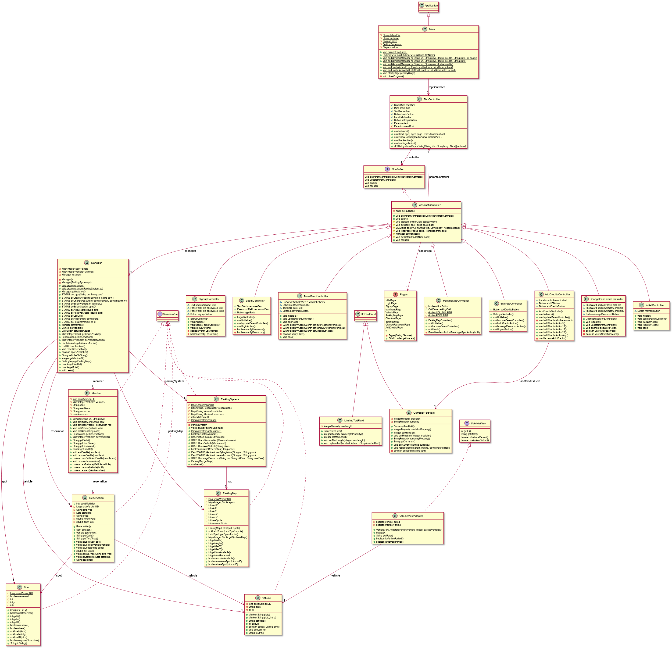

**CRC Cards**

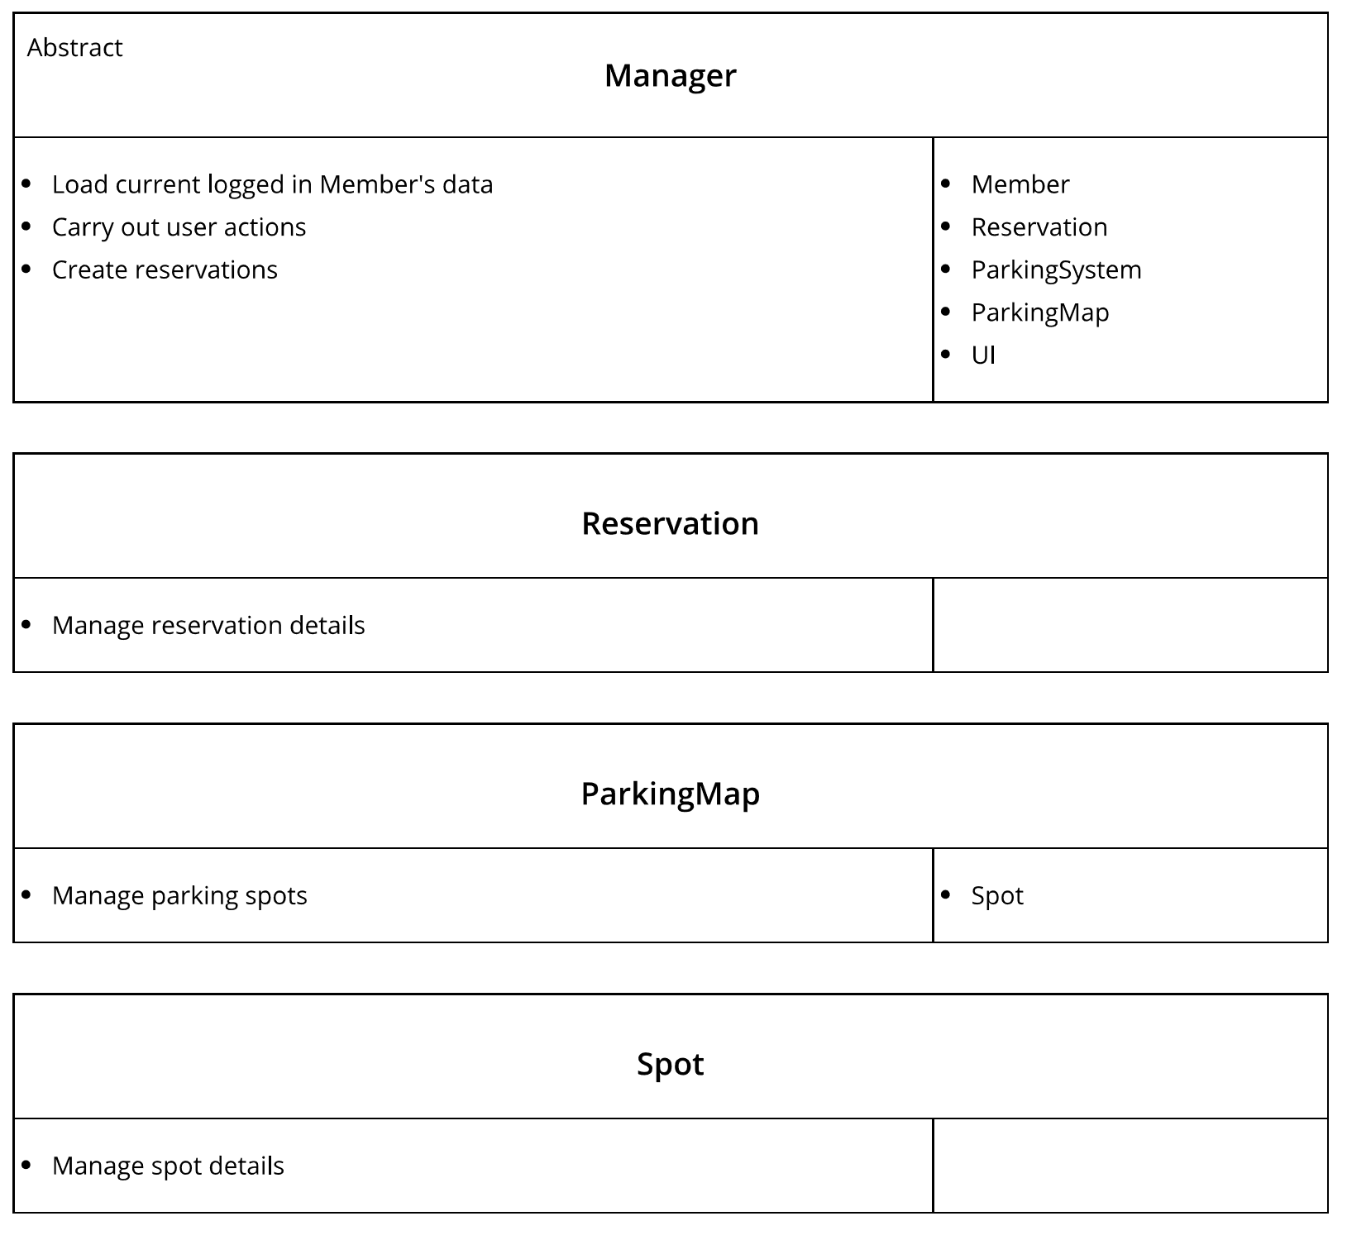

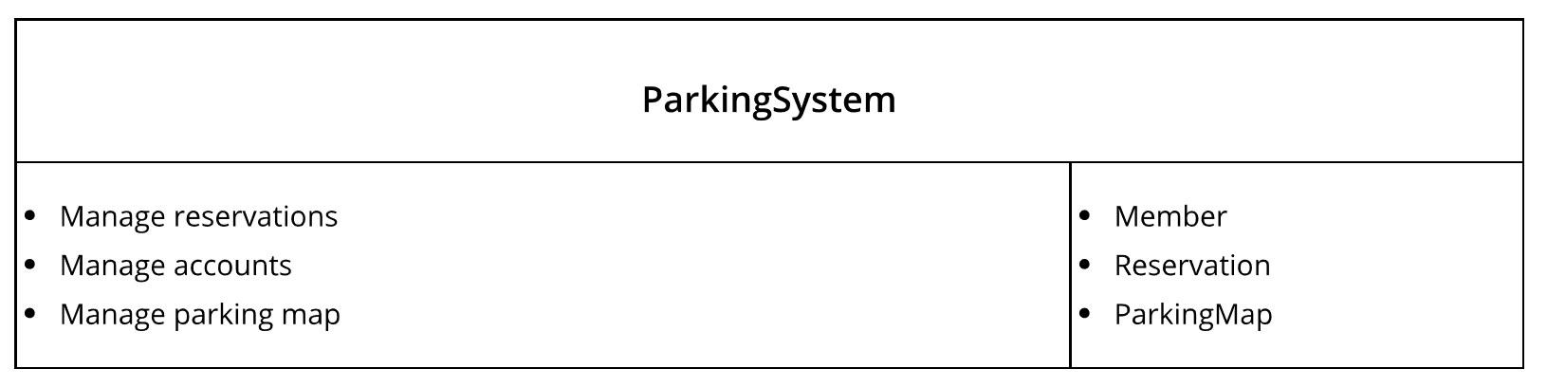

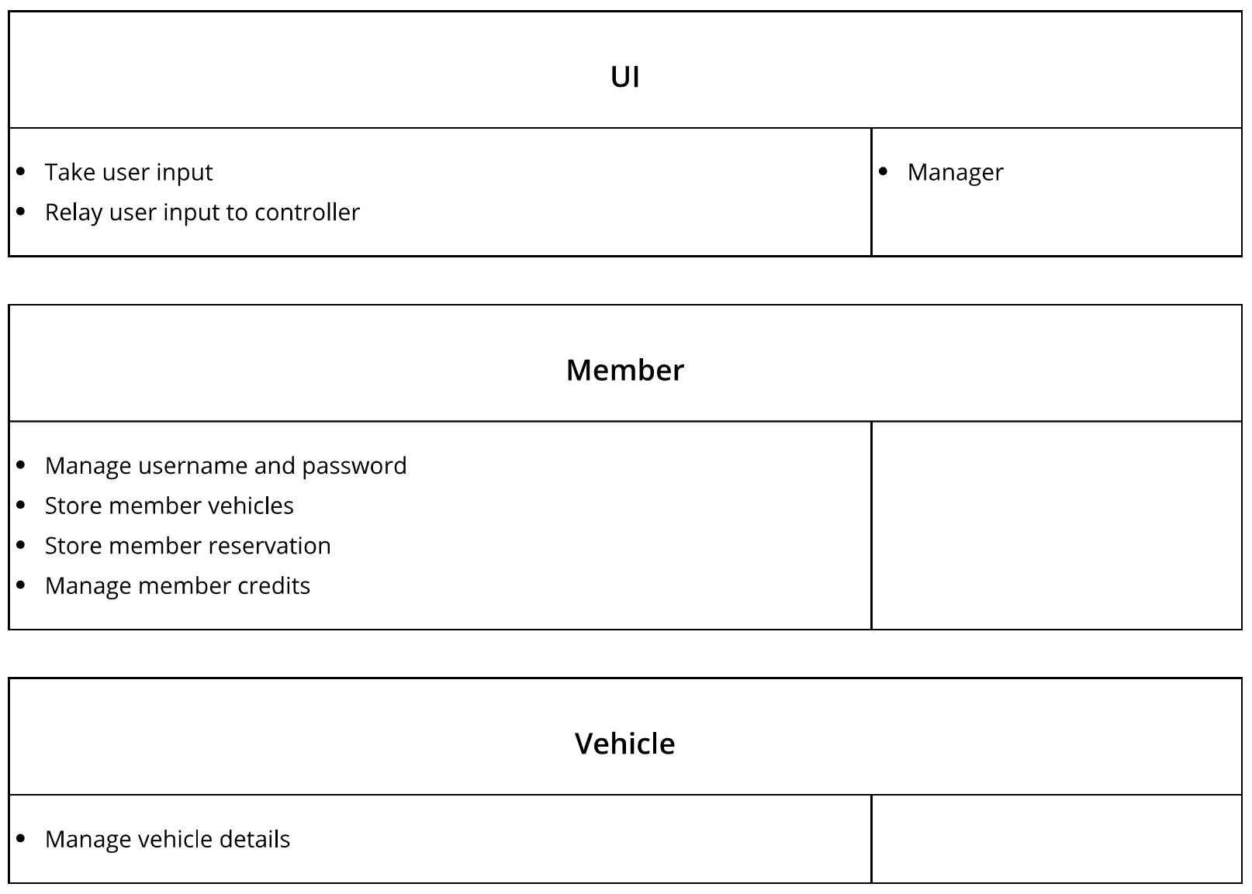

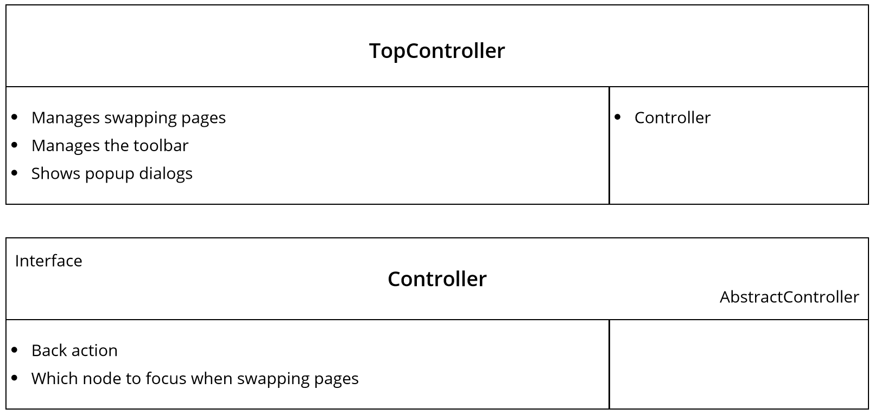

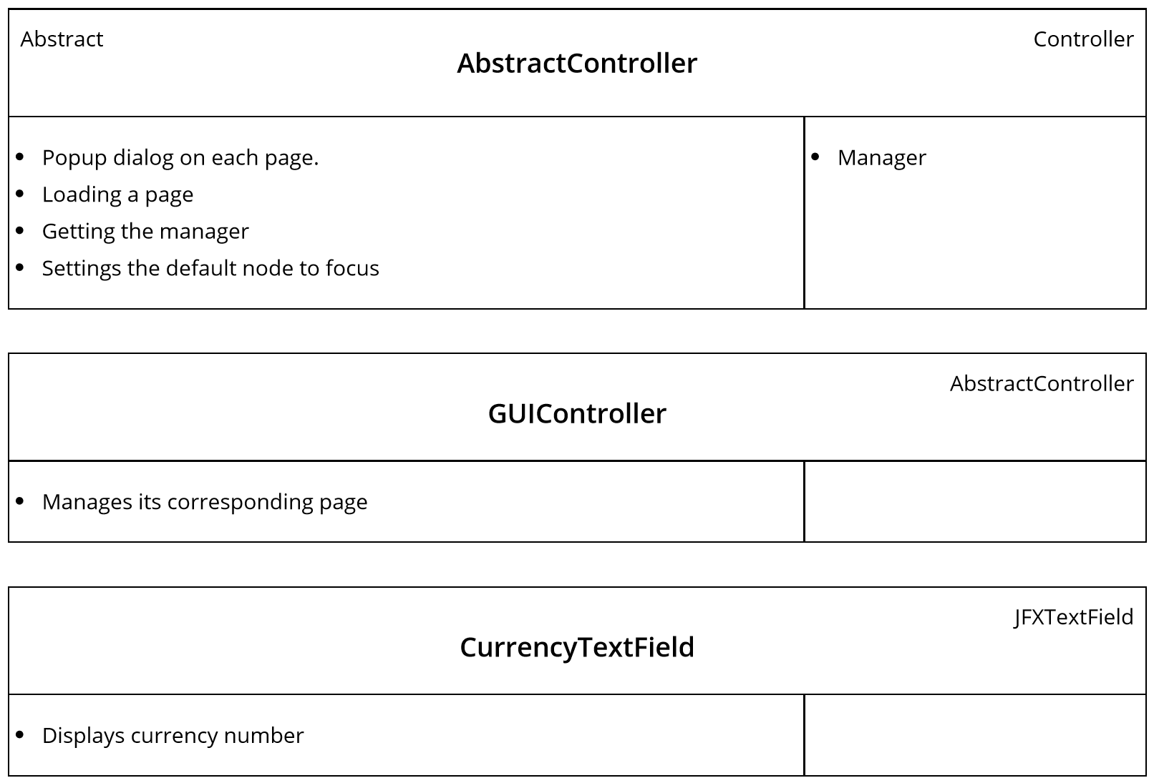

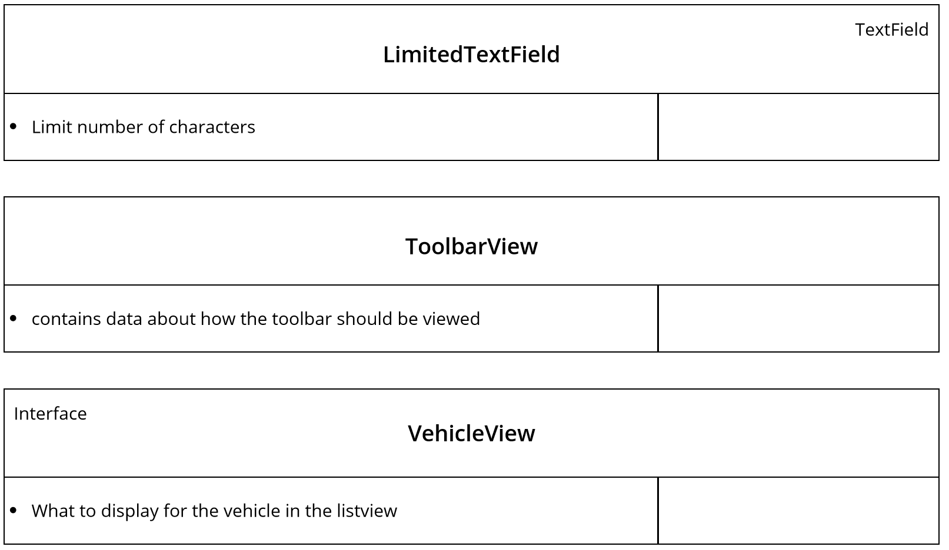

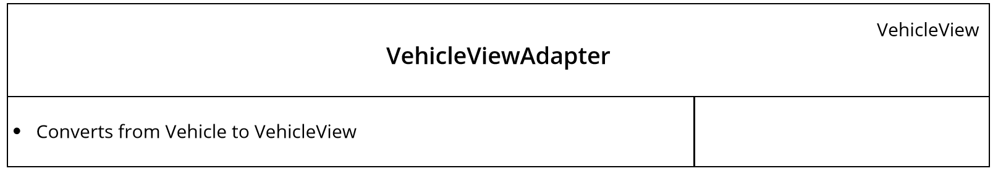

**Sequence Diagrams**

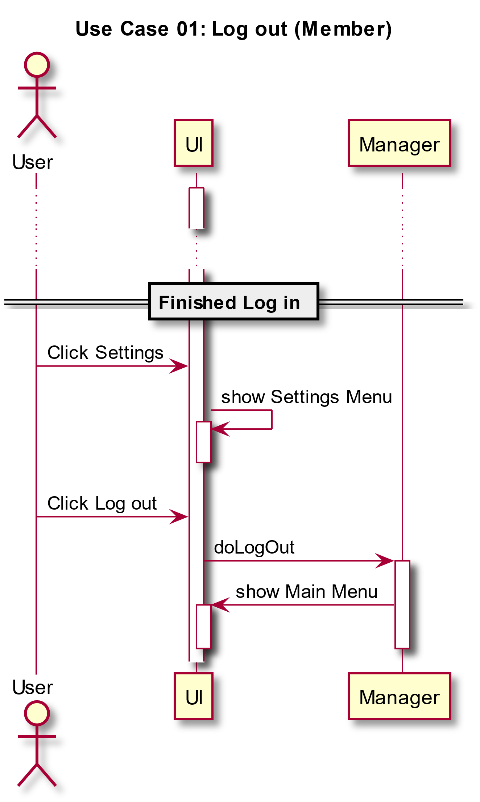

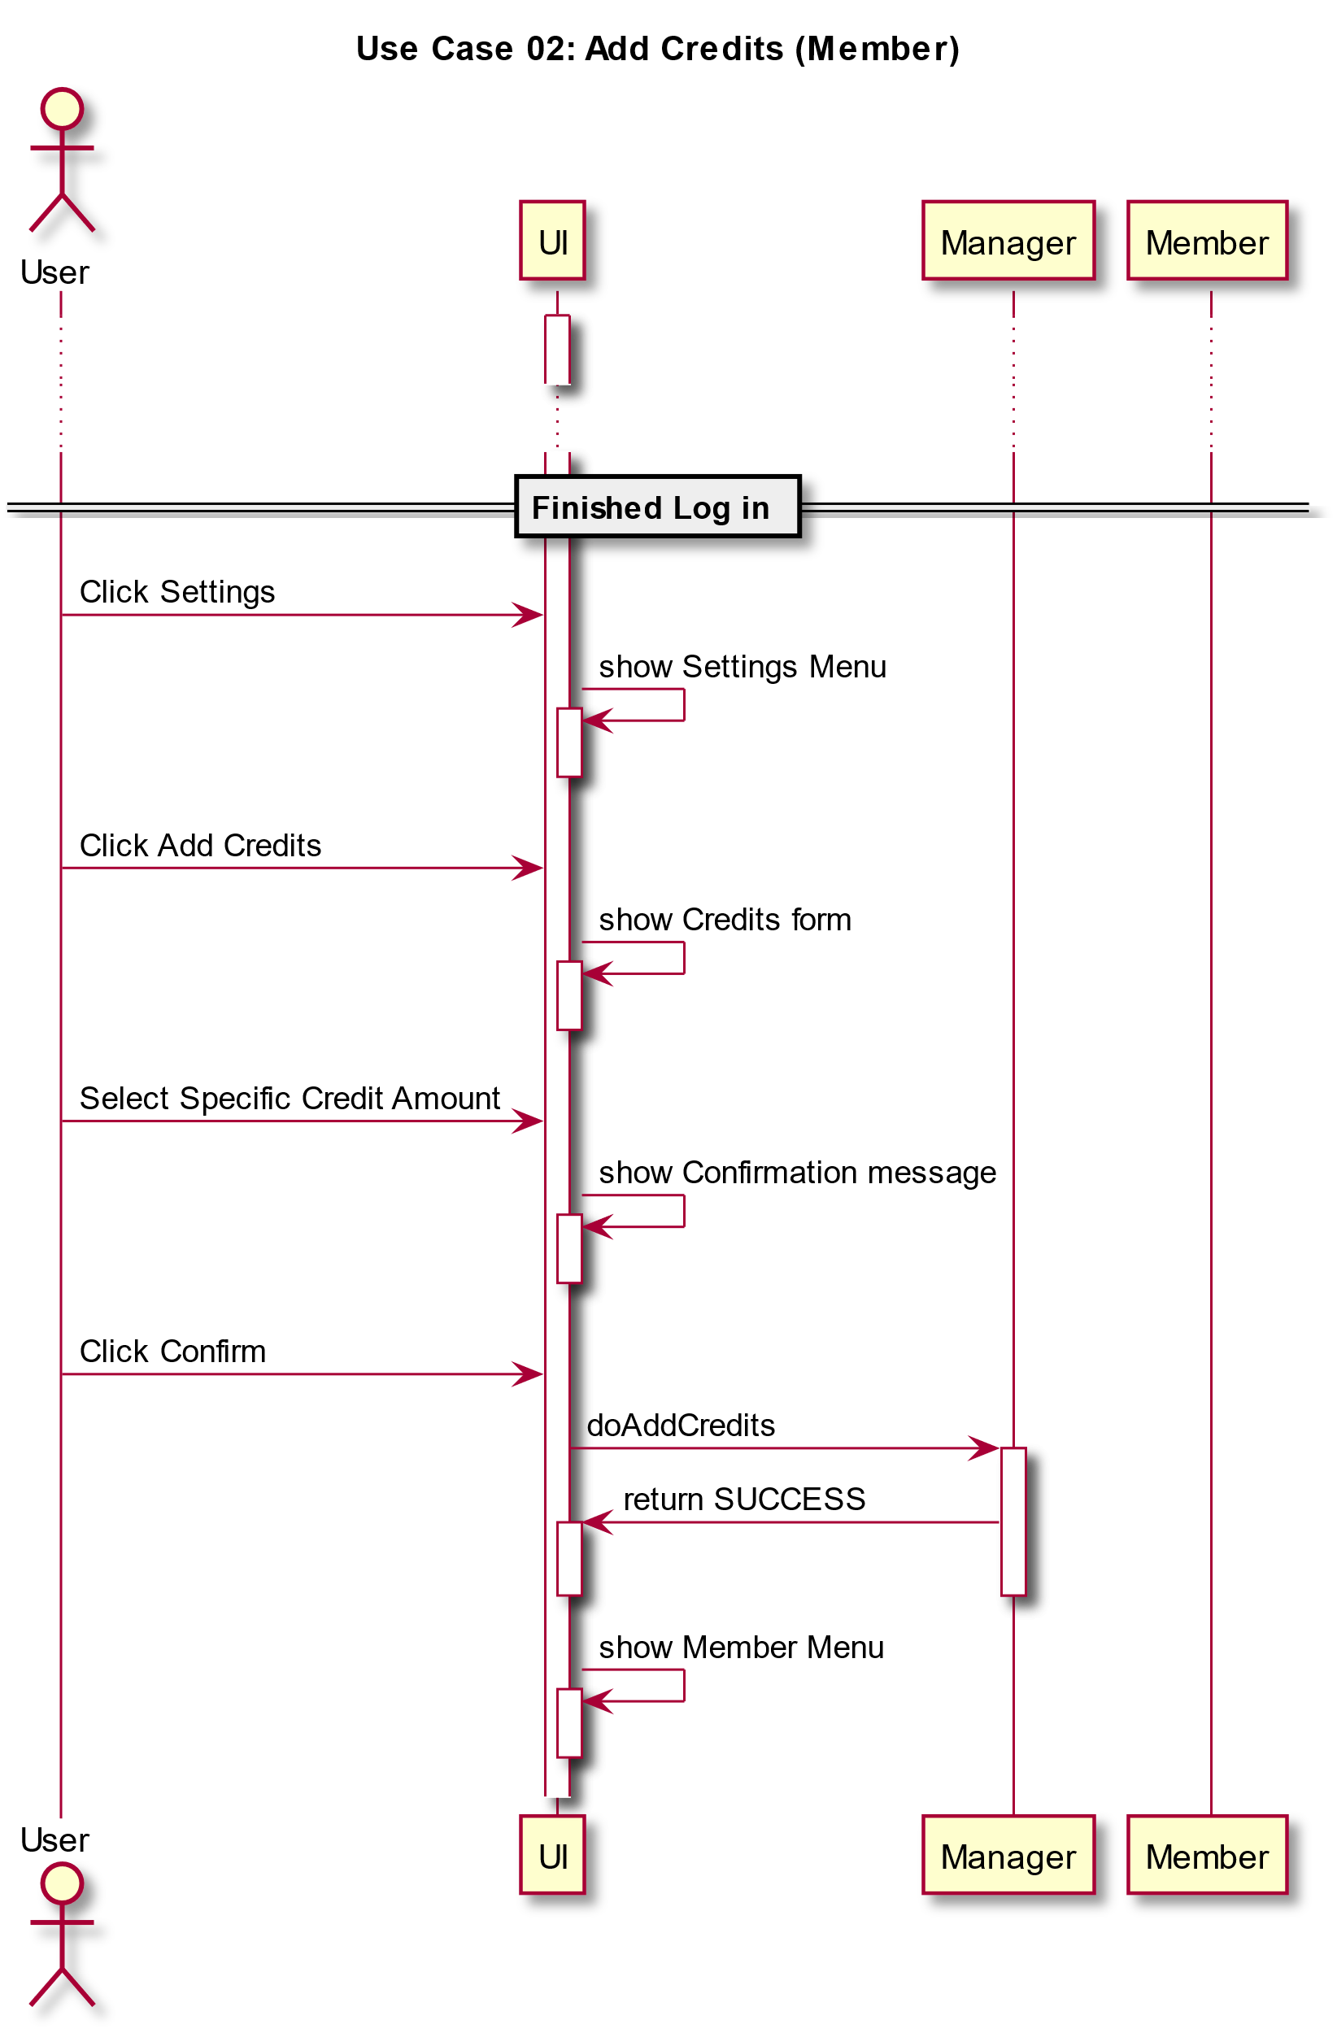

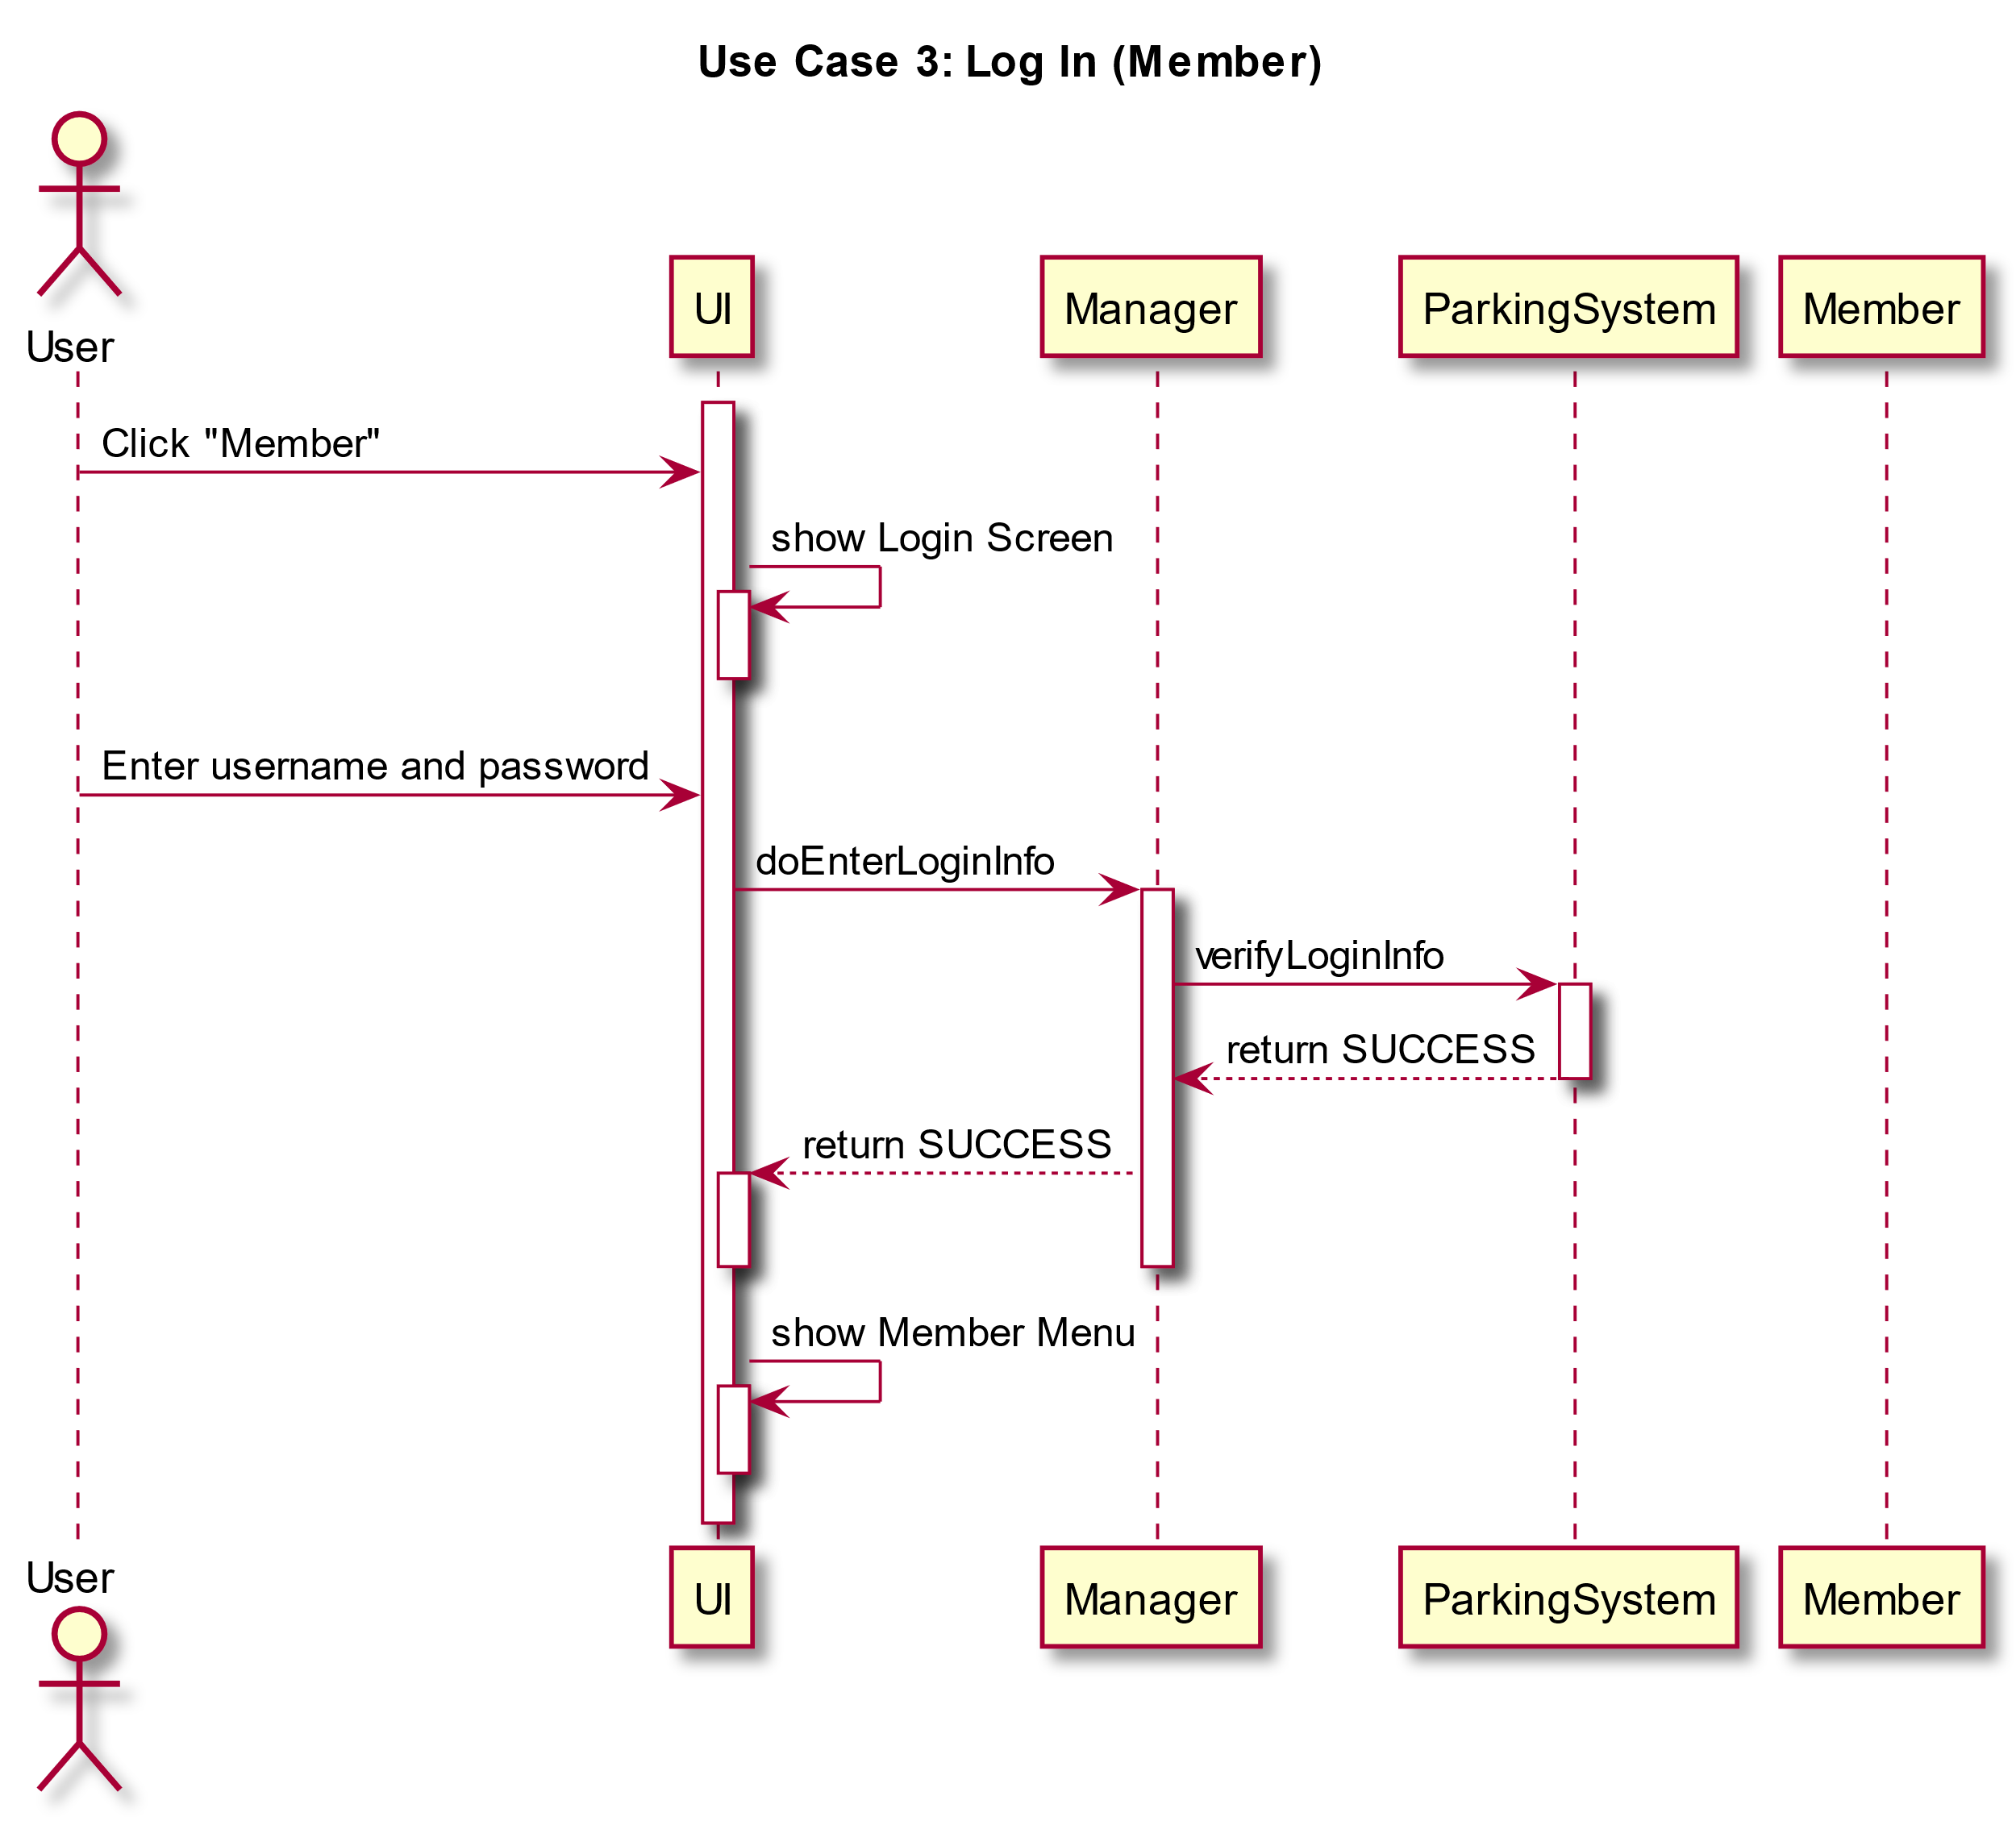

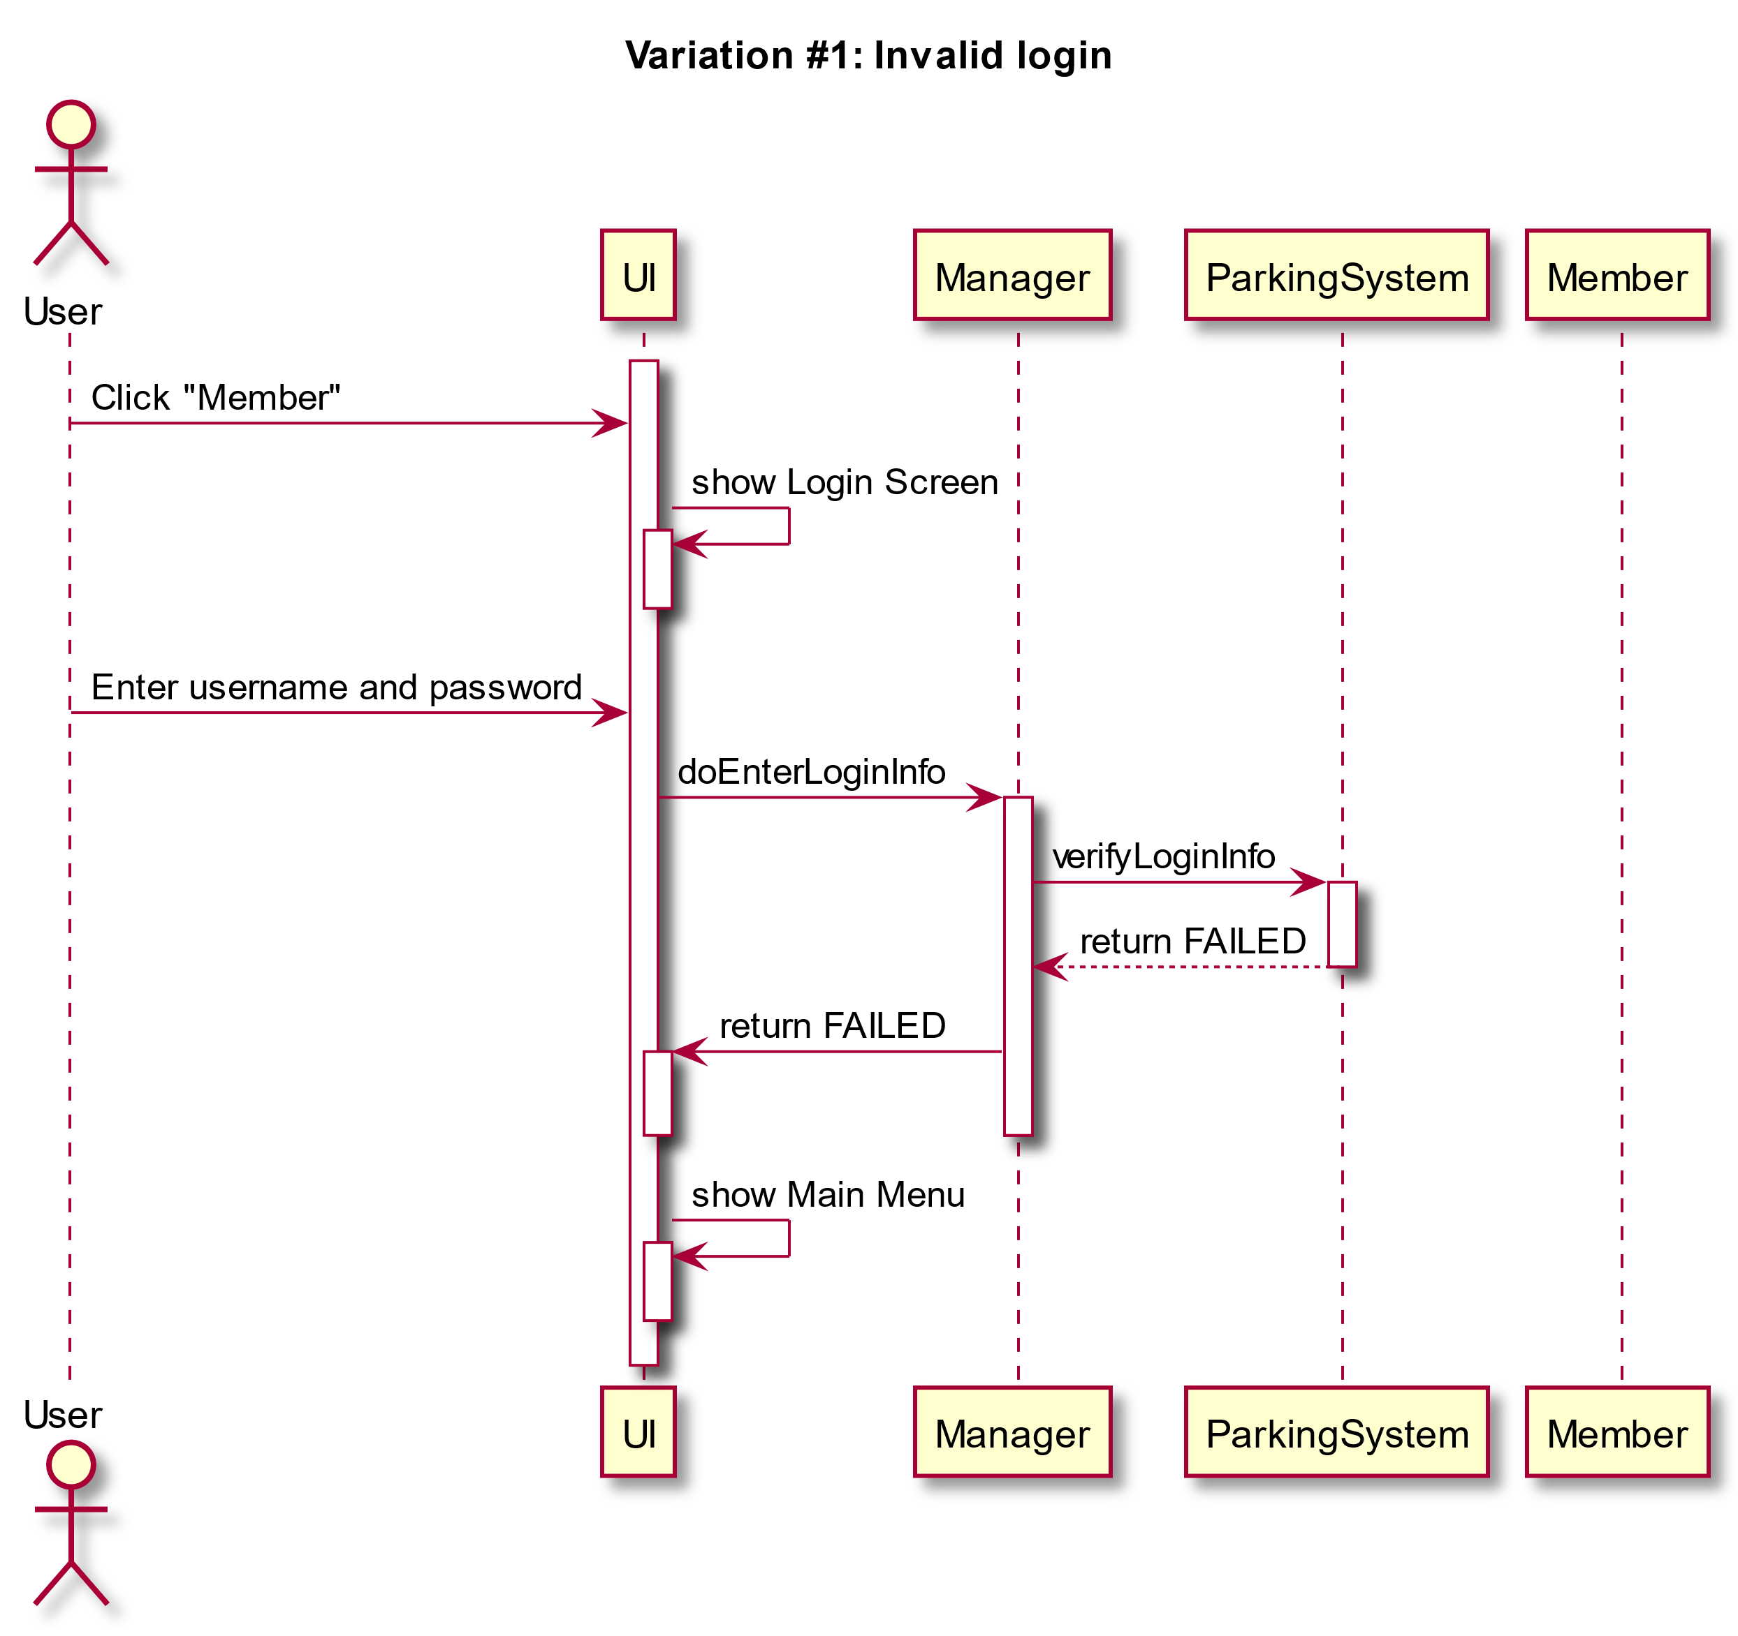

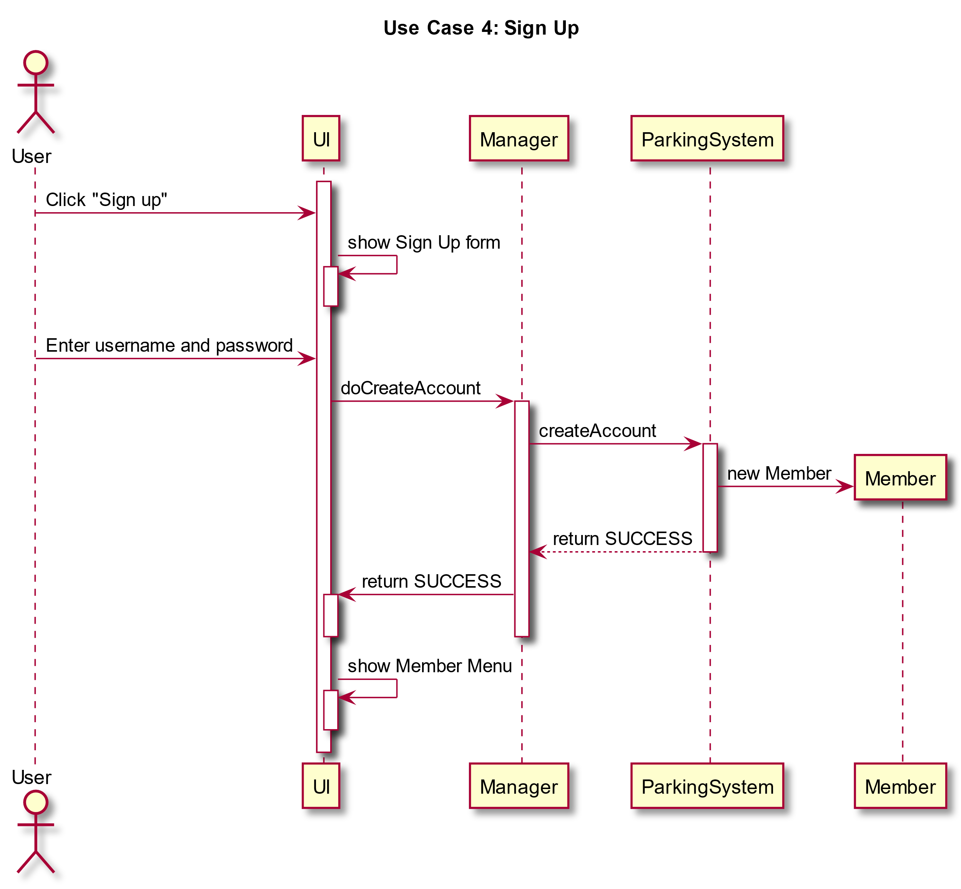

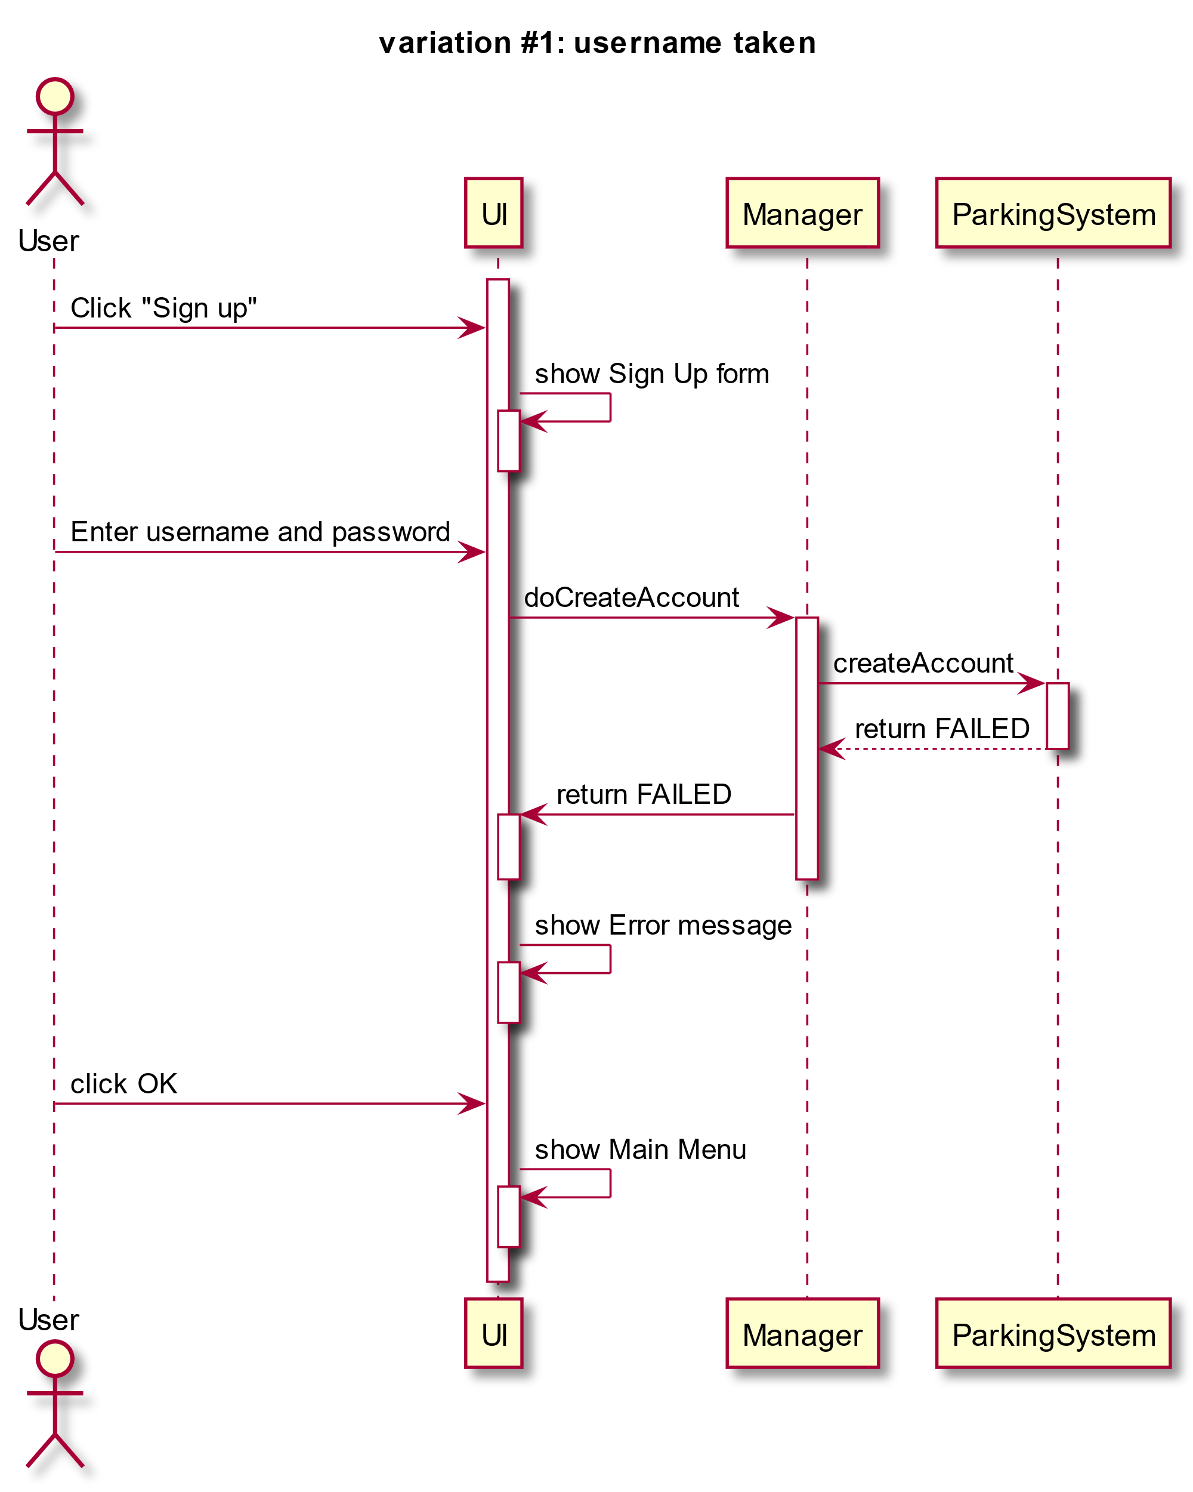

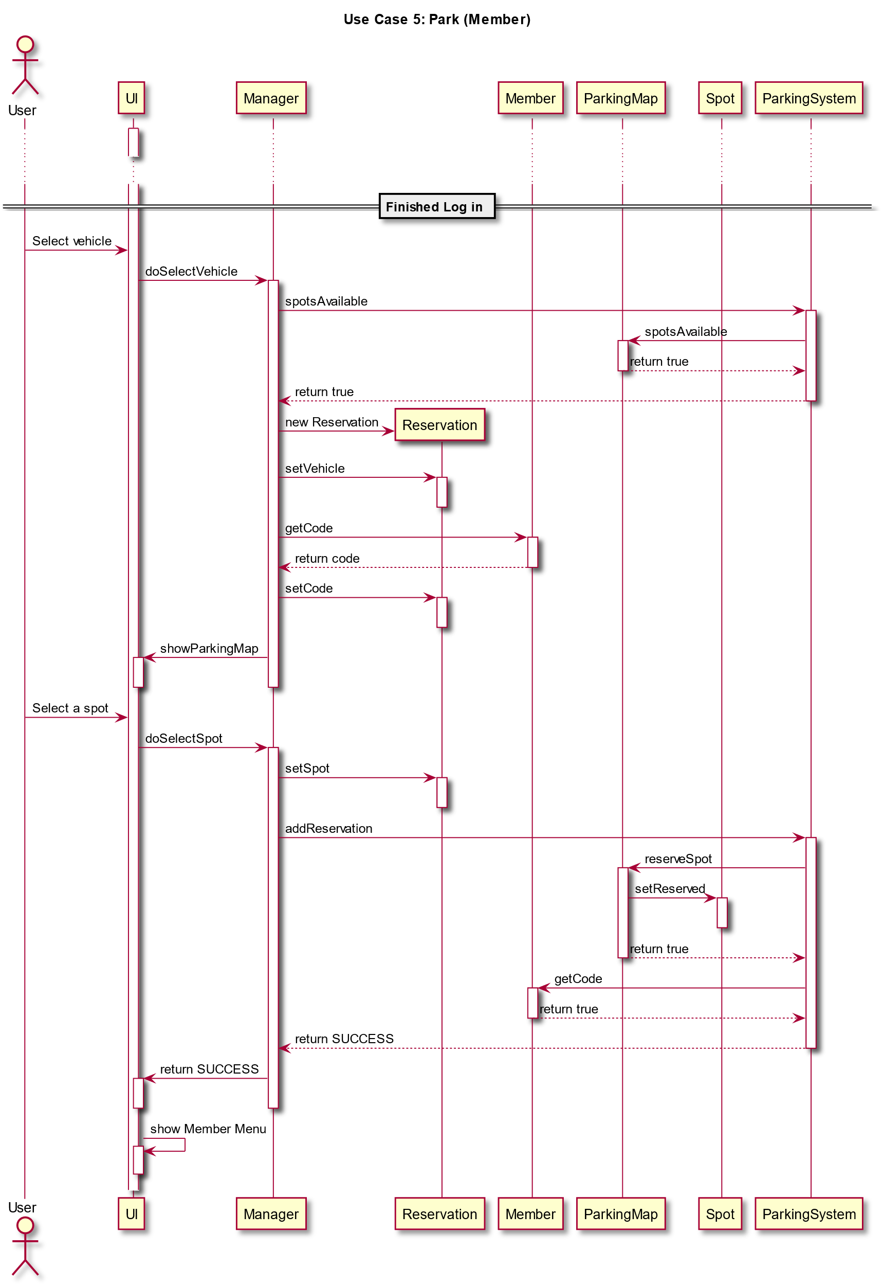

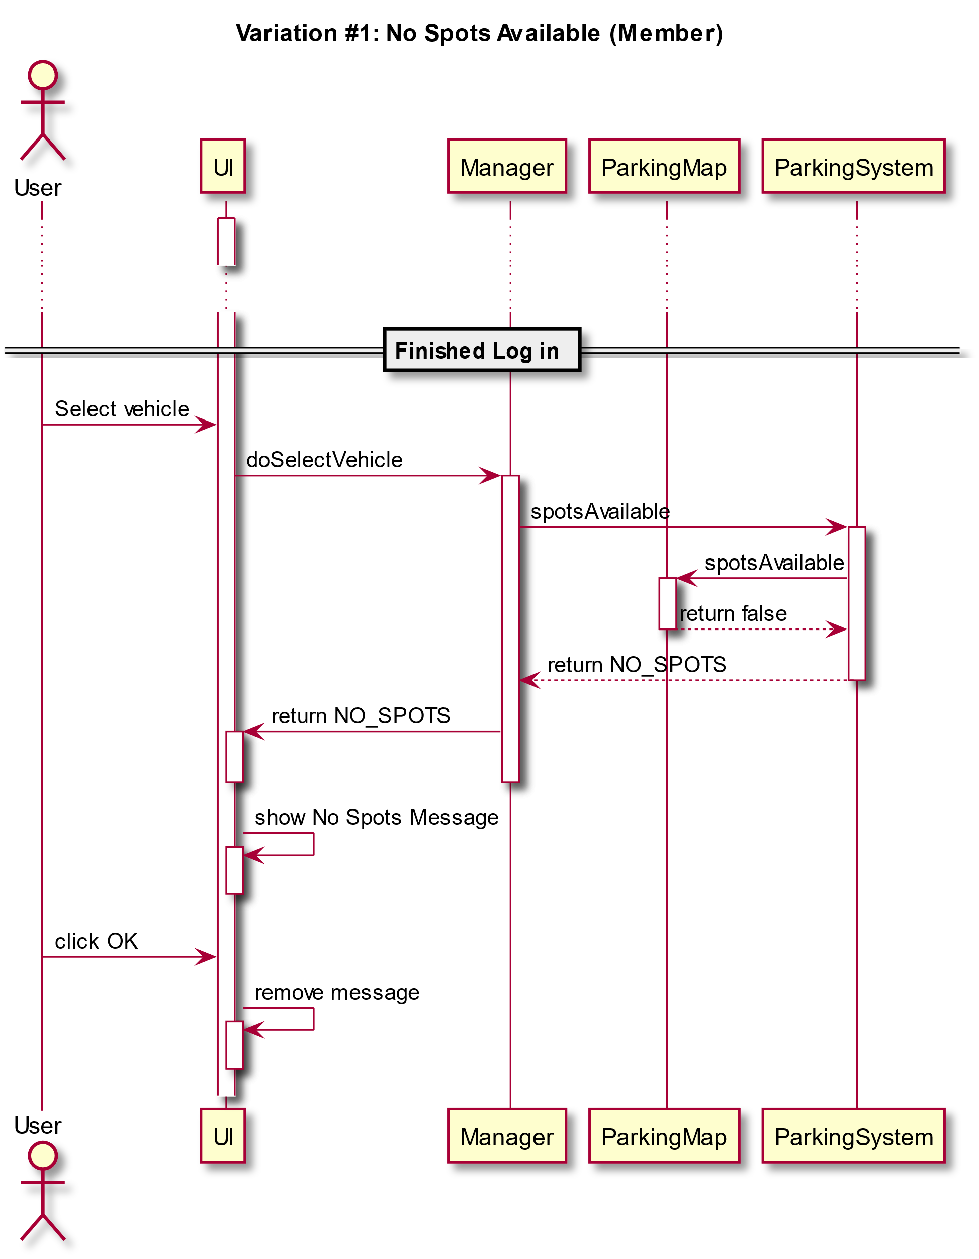

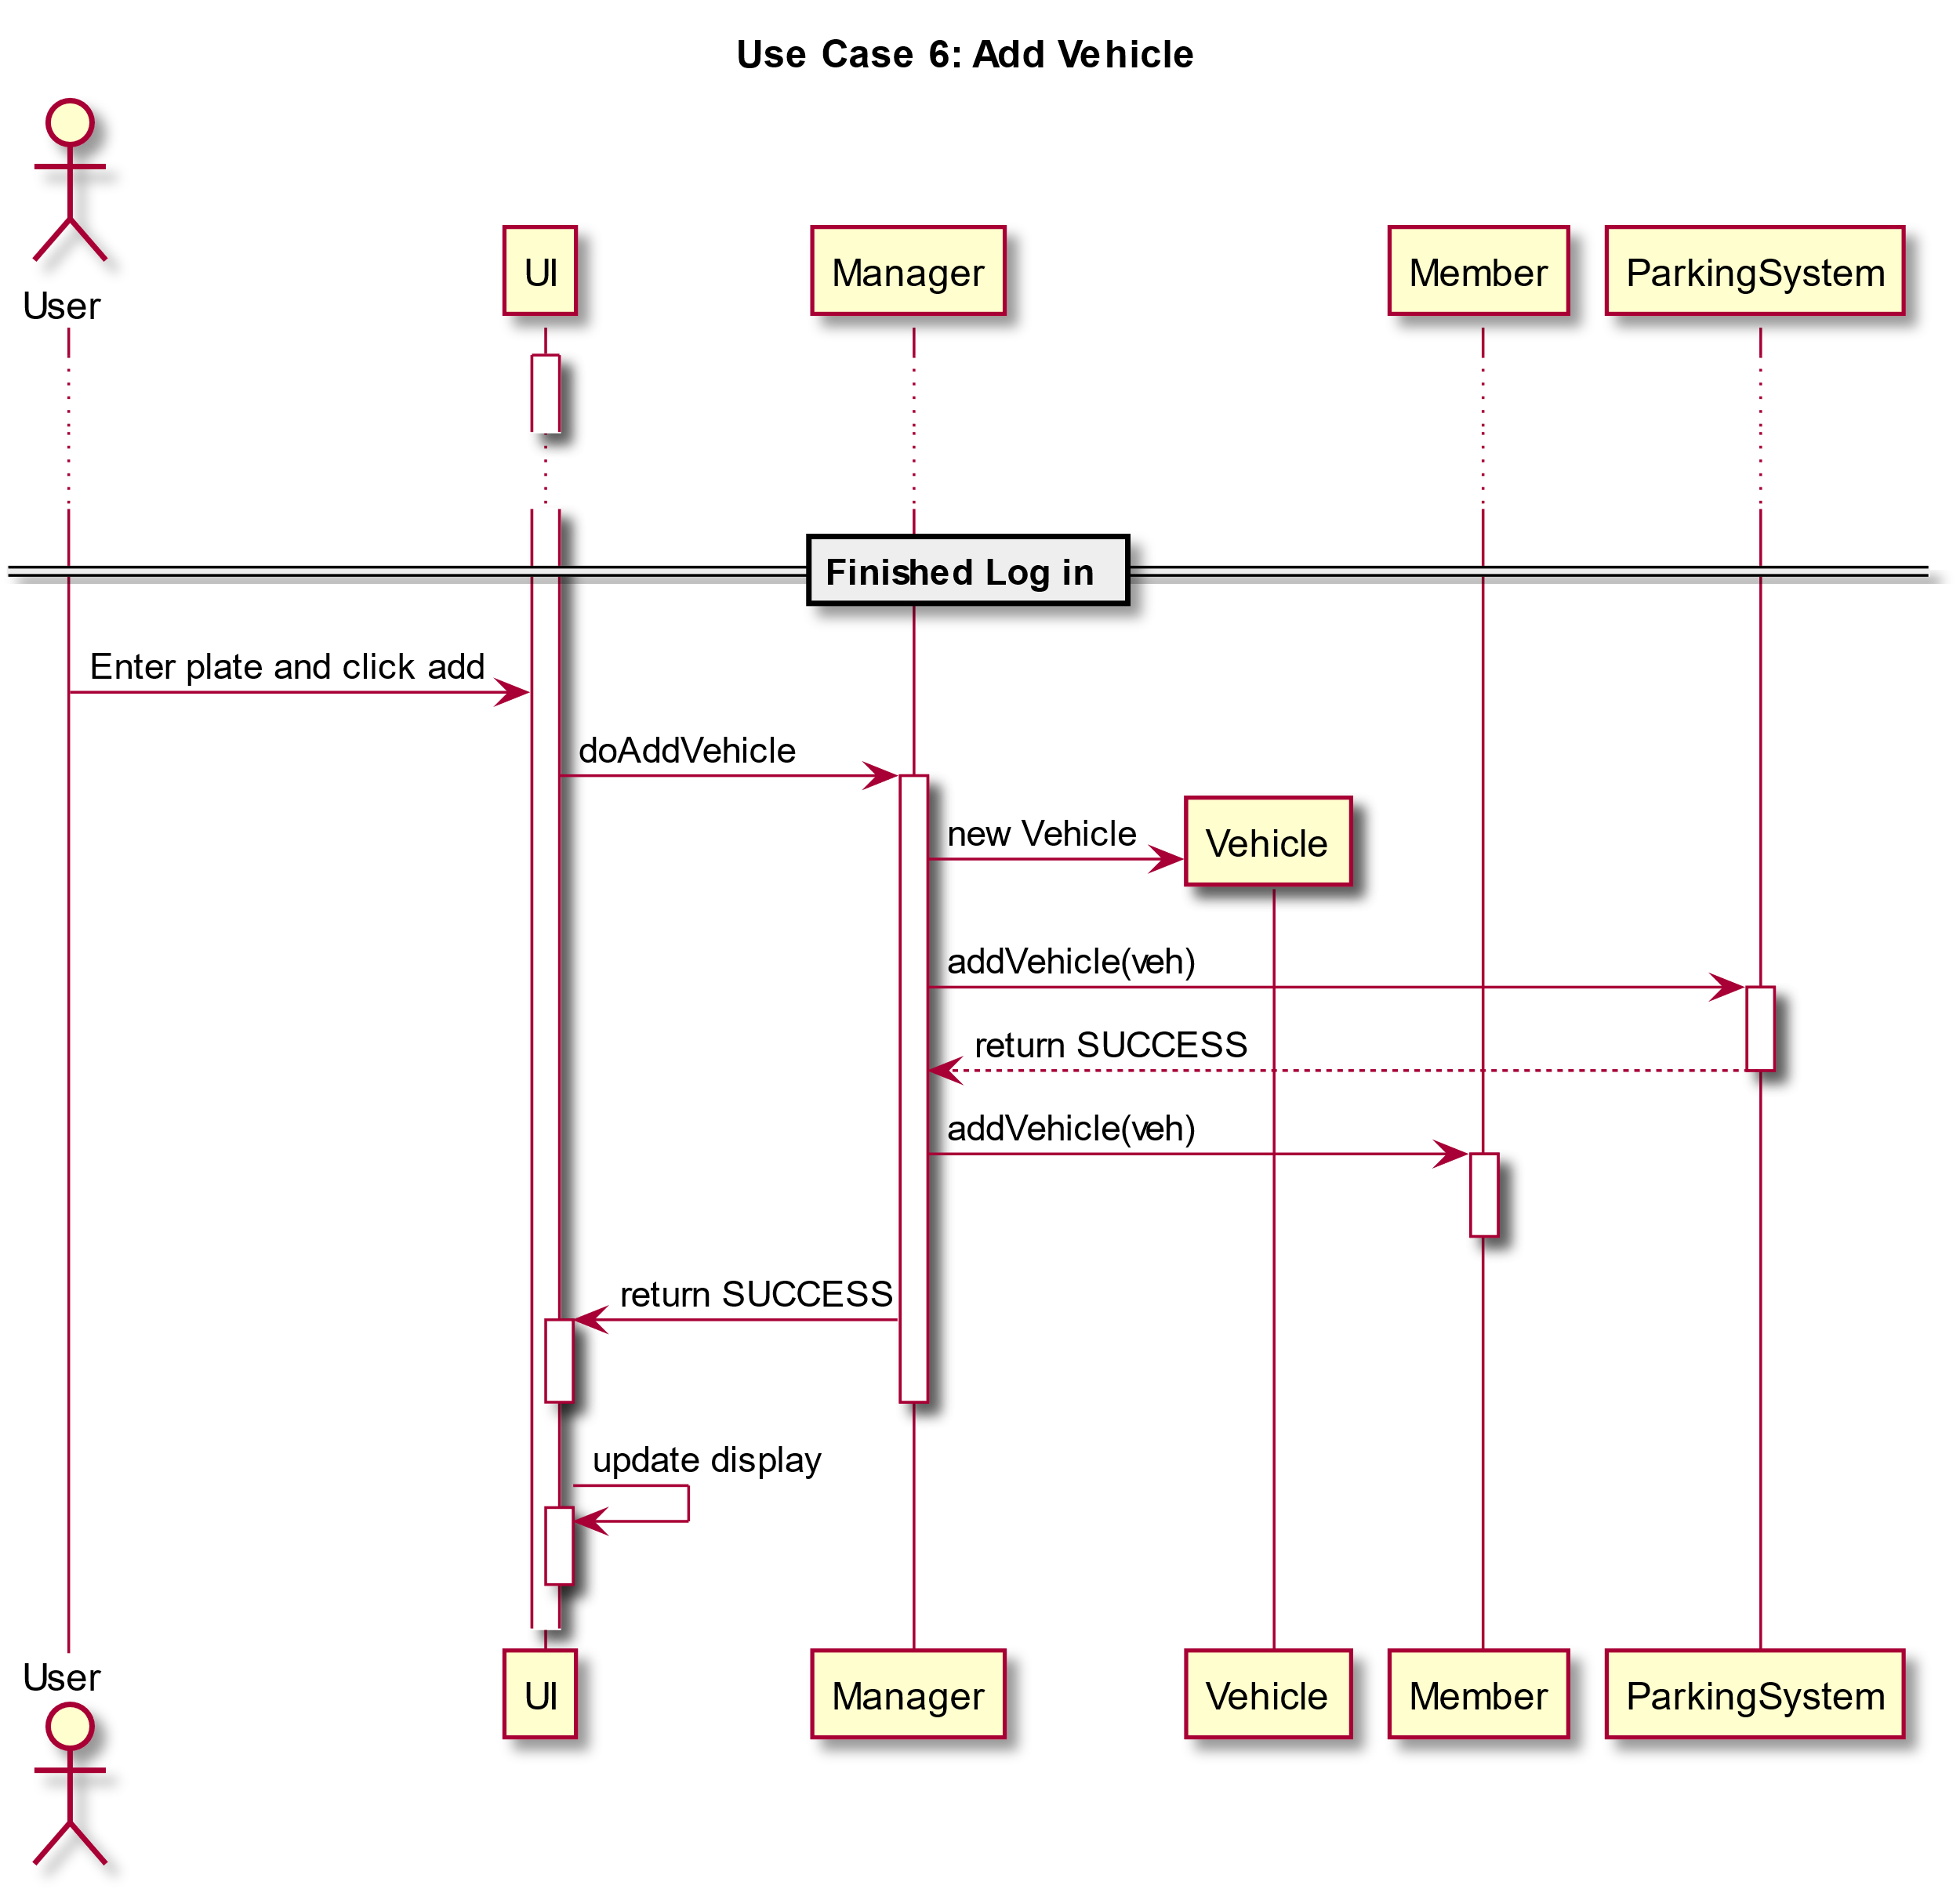

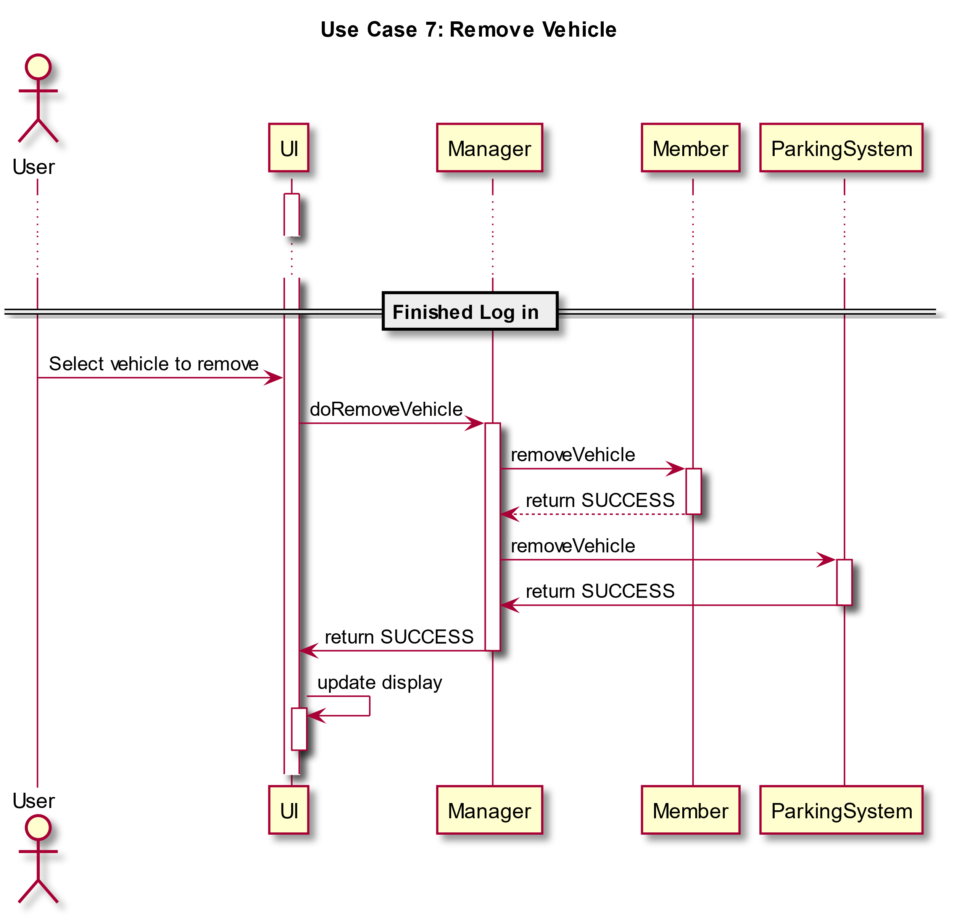

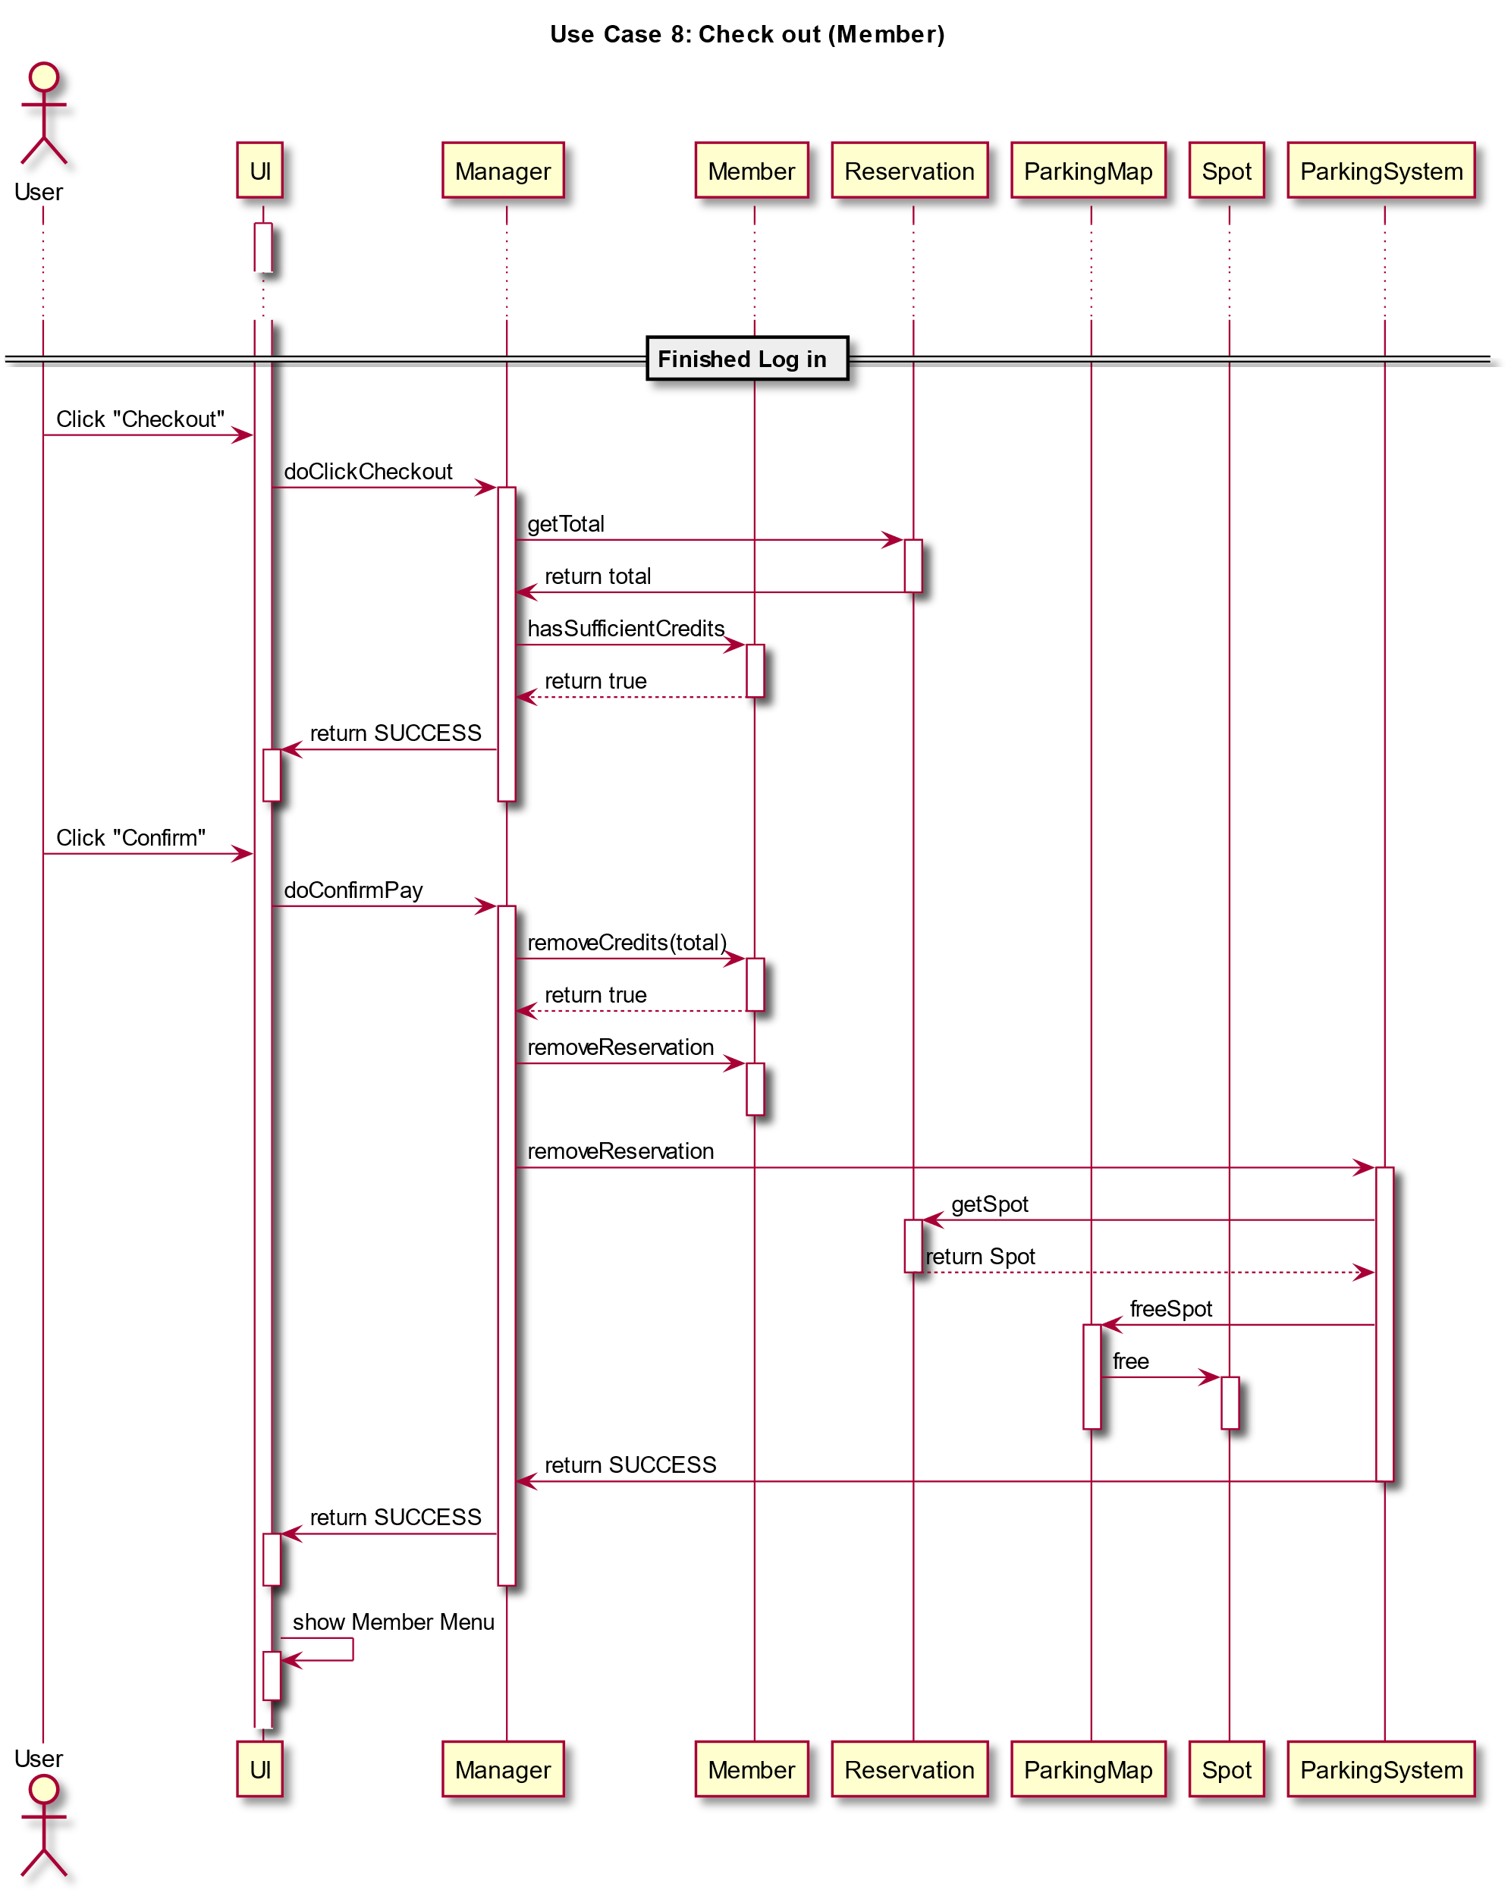

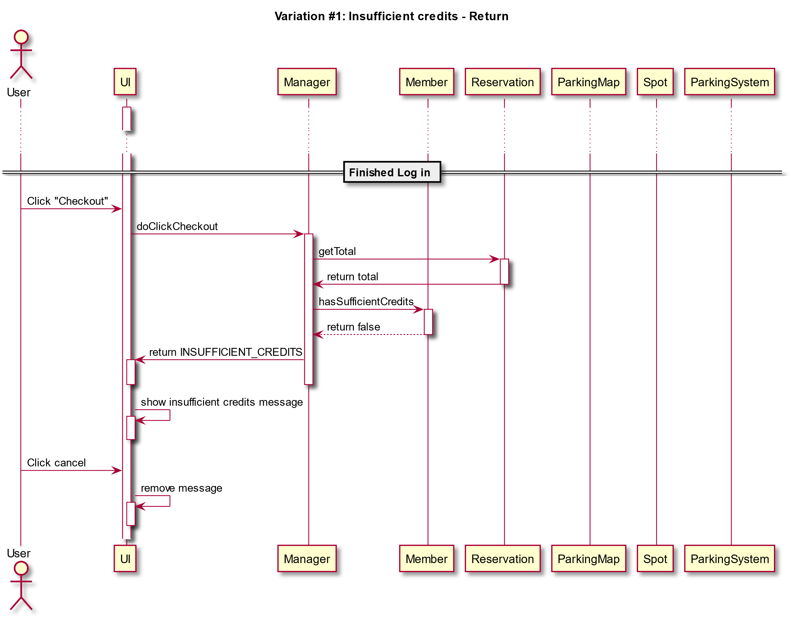

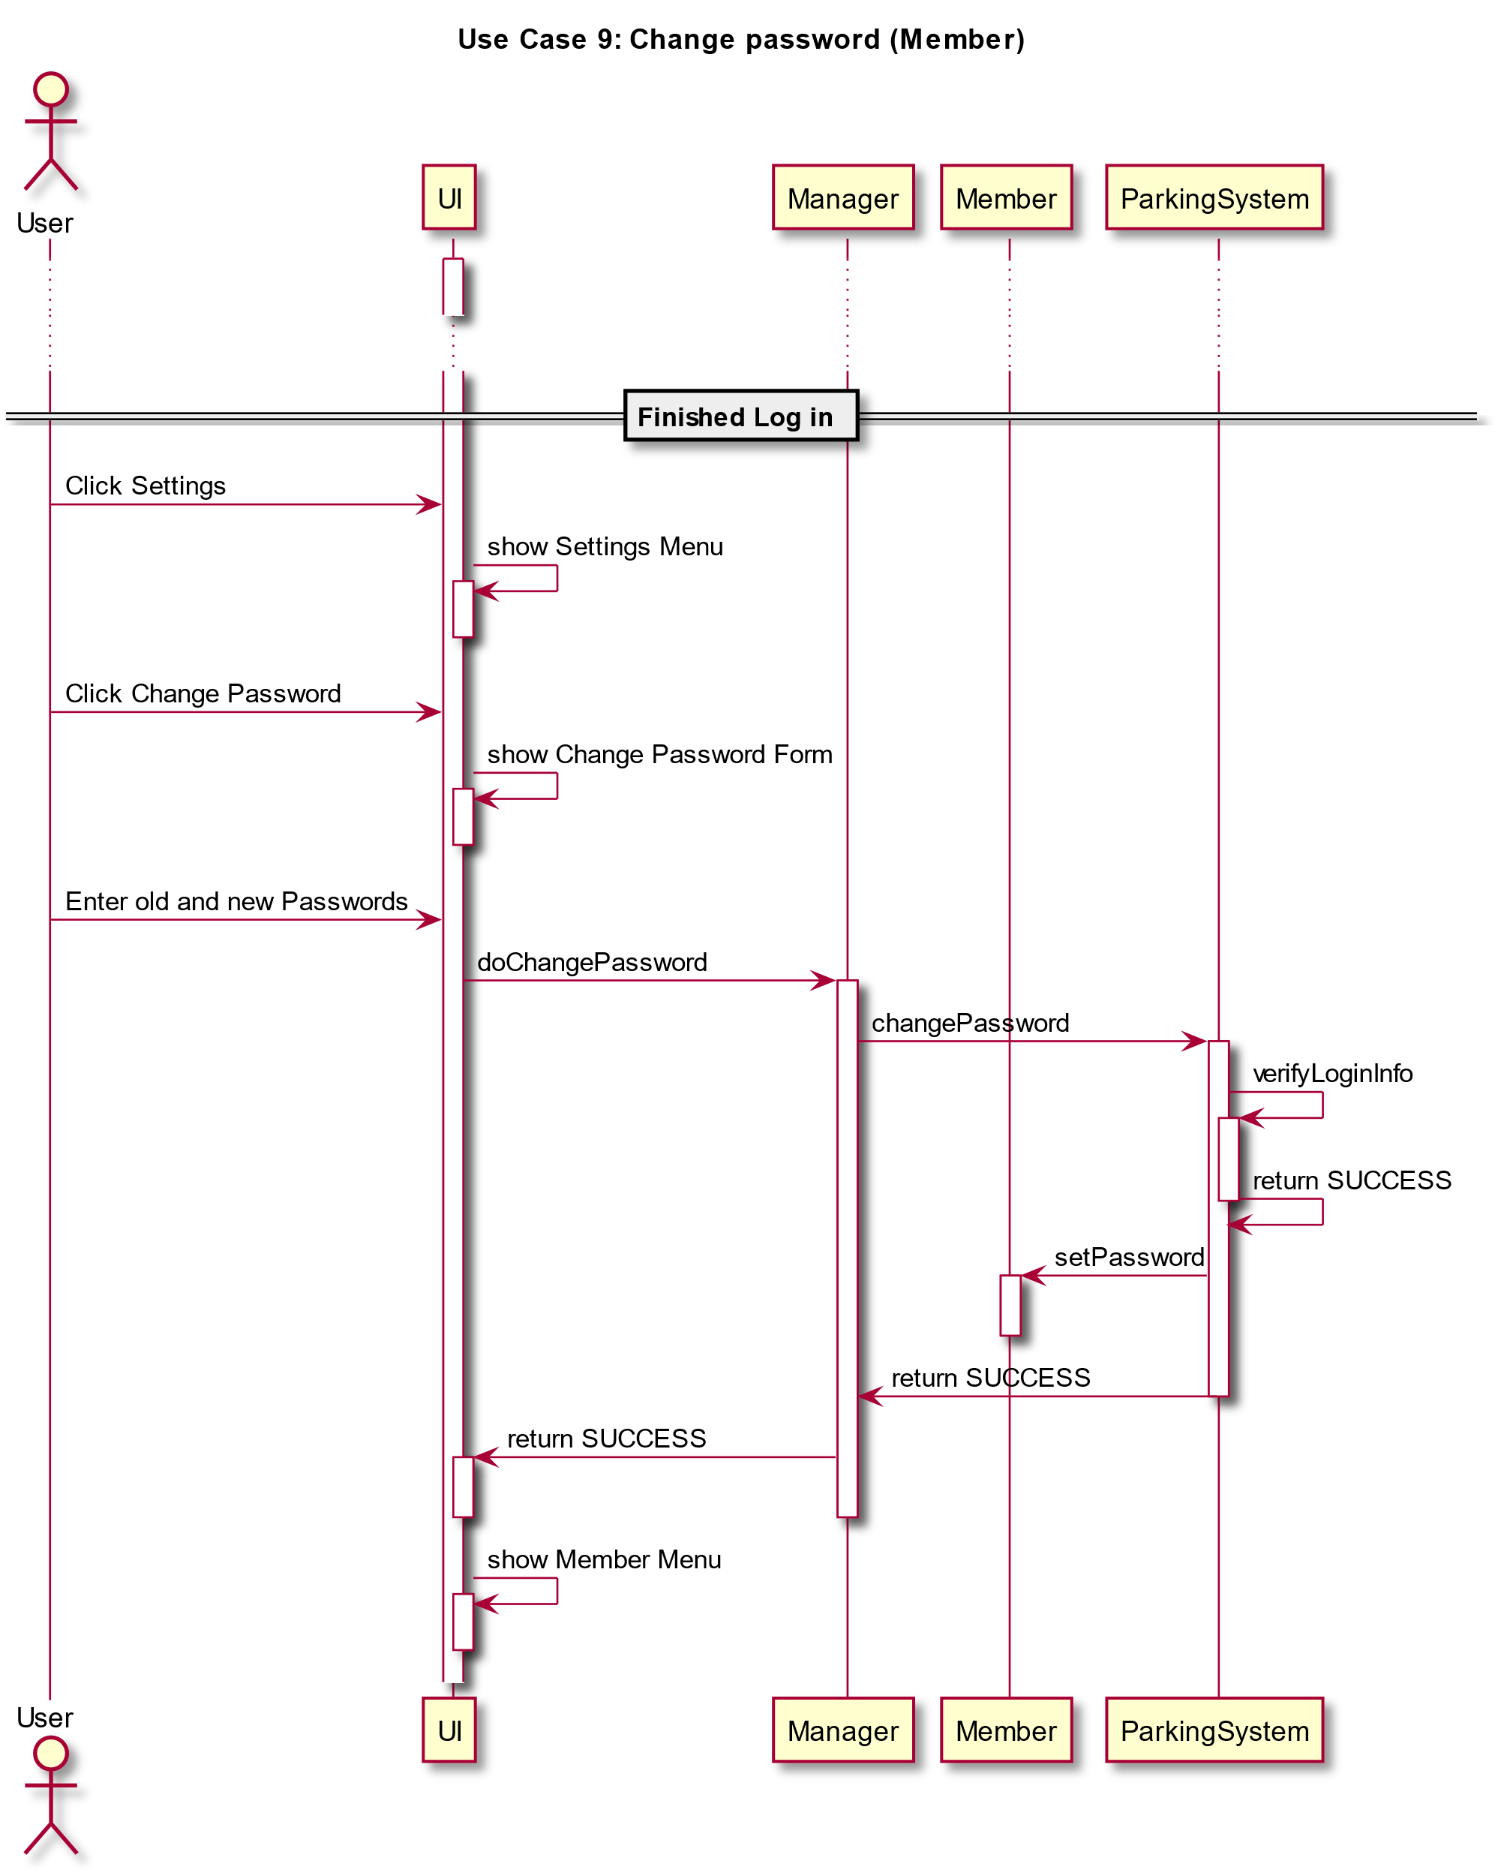

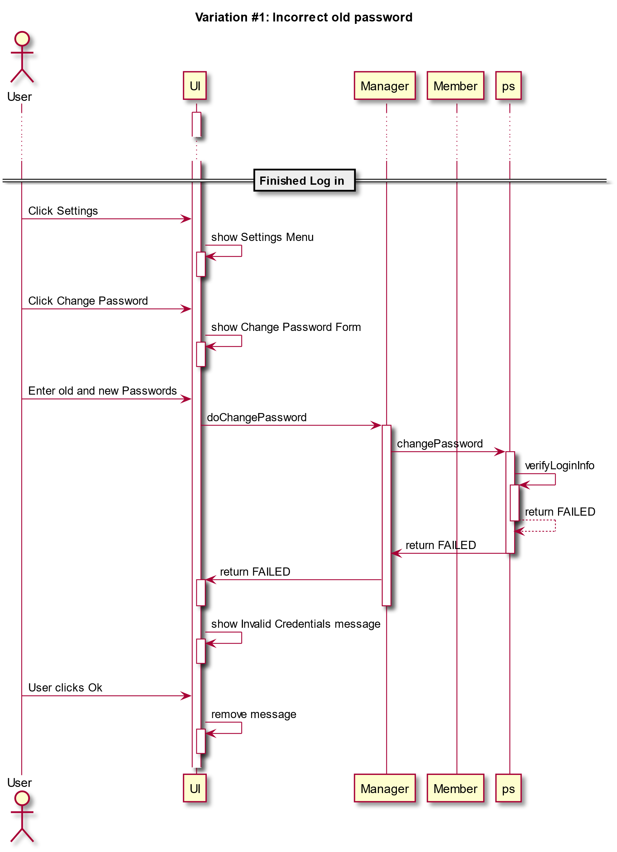

**State Diagram**

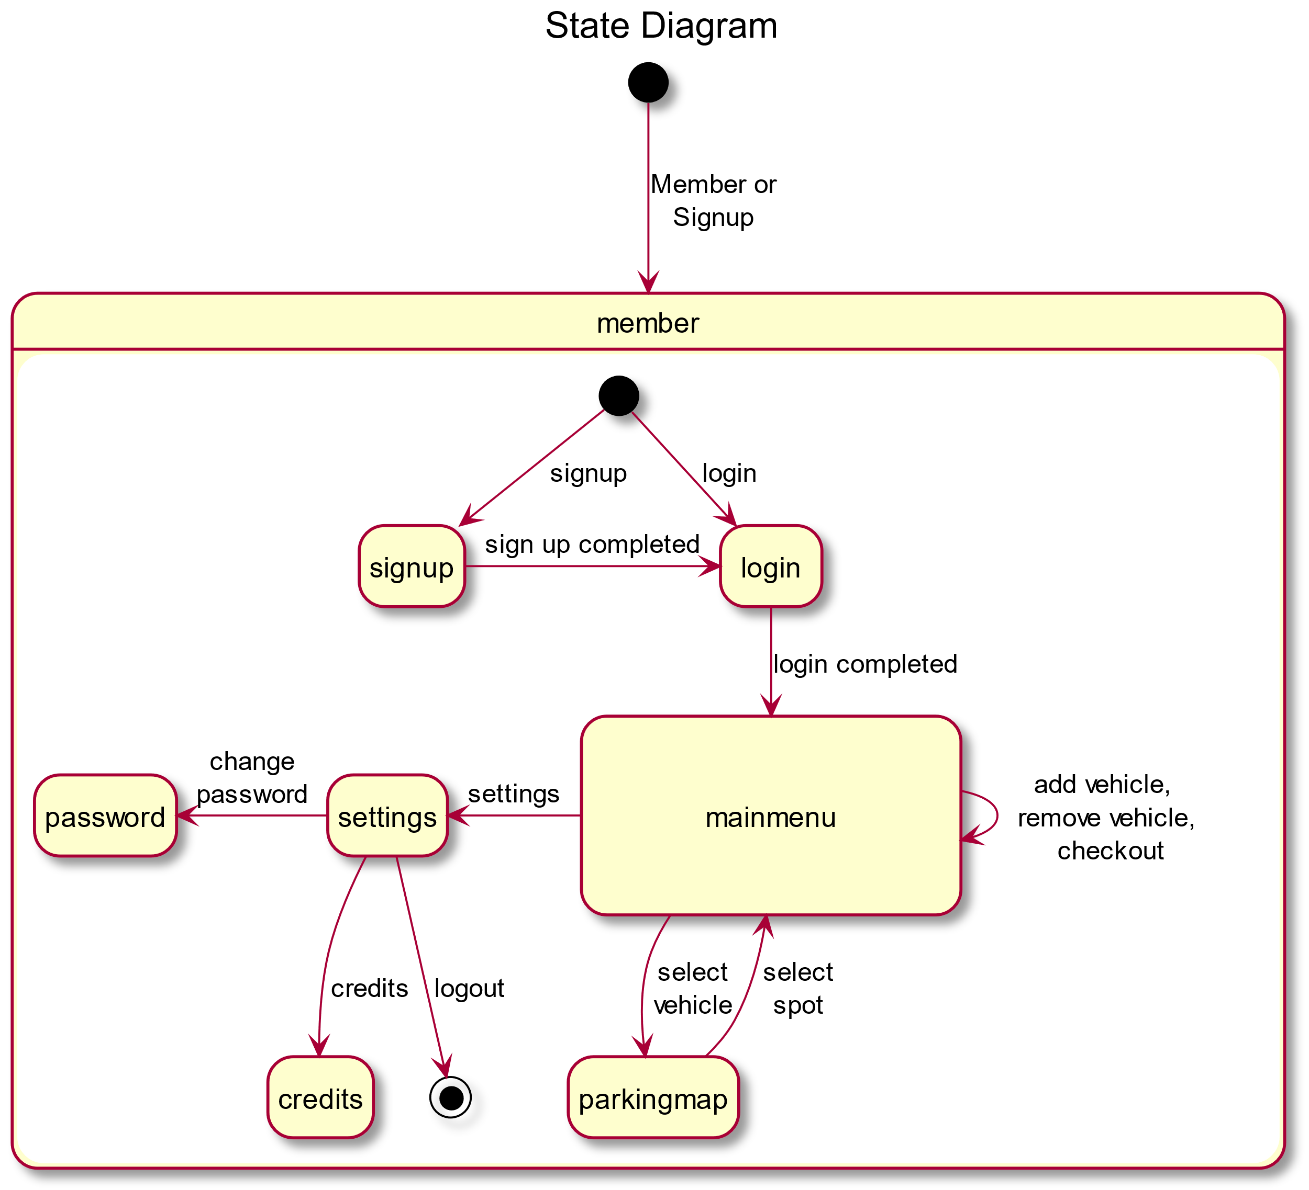

**Design Patterns**

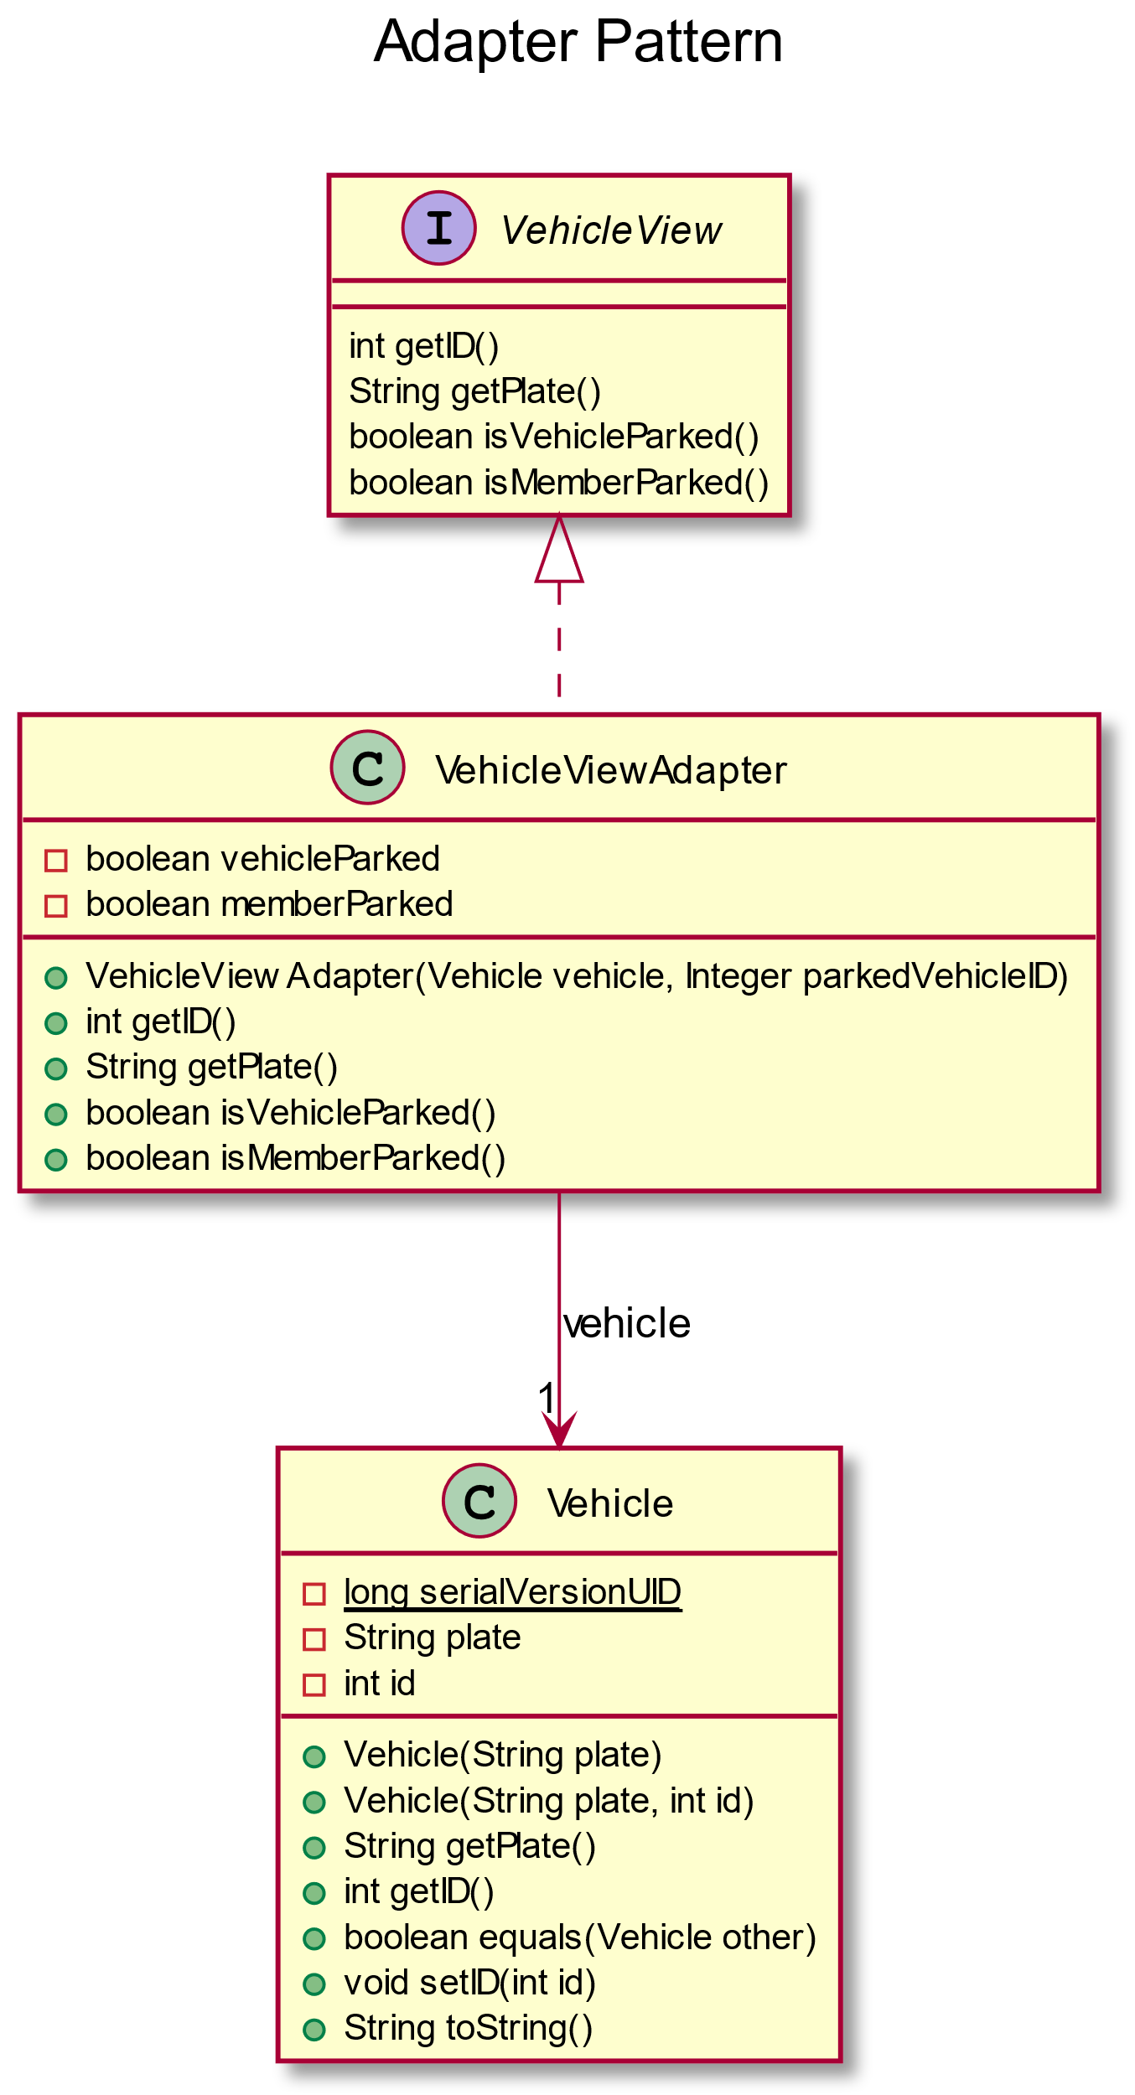

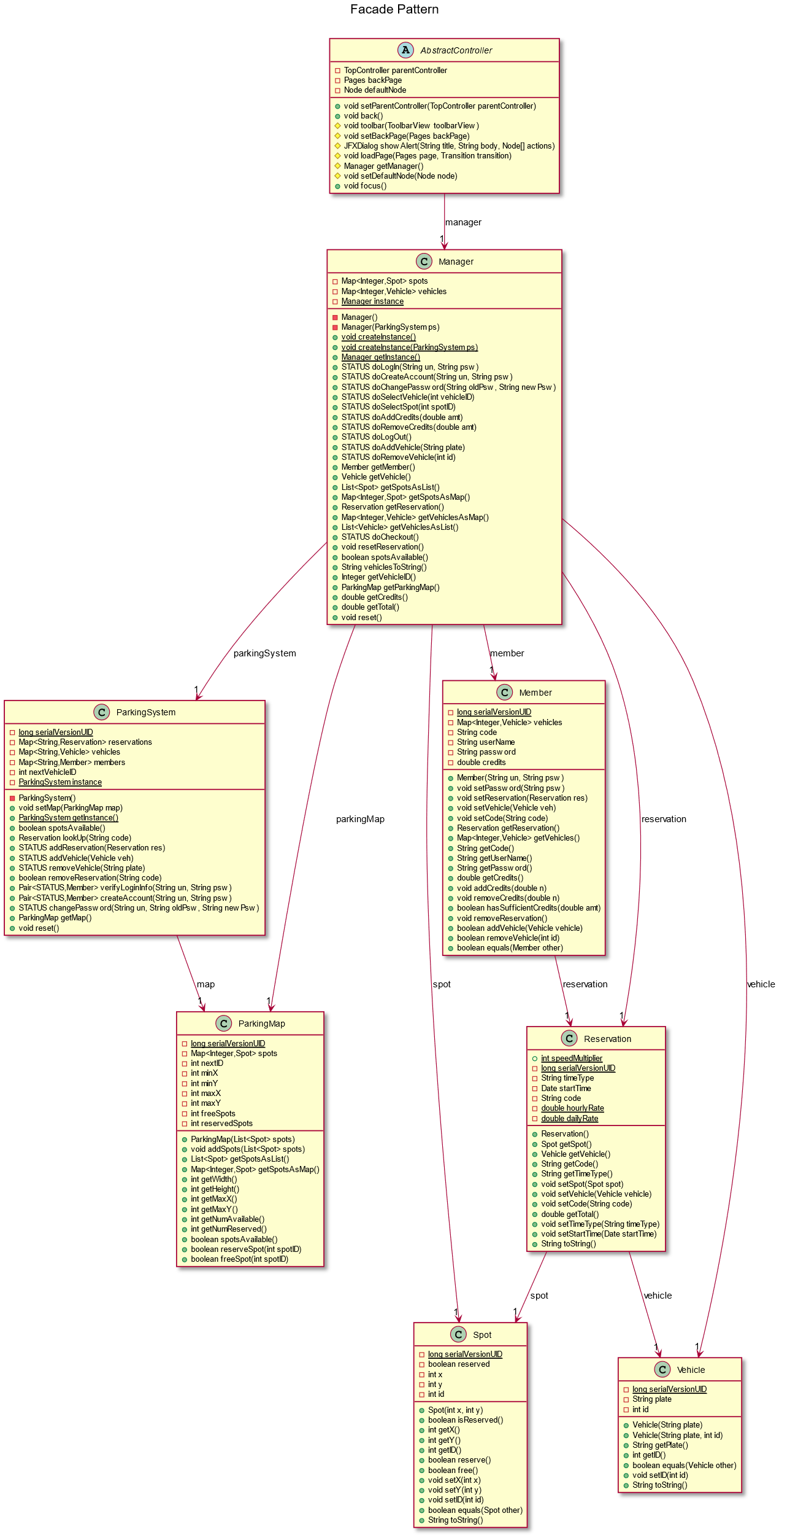

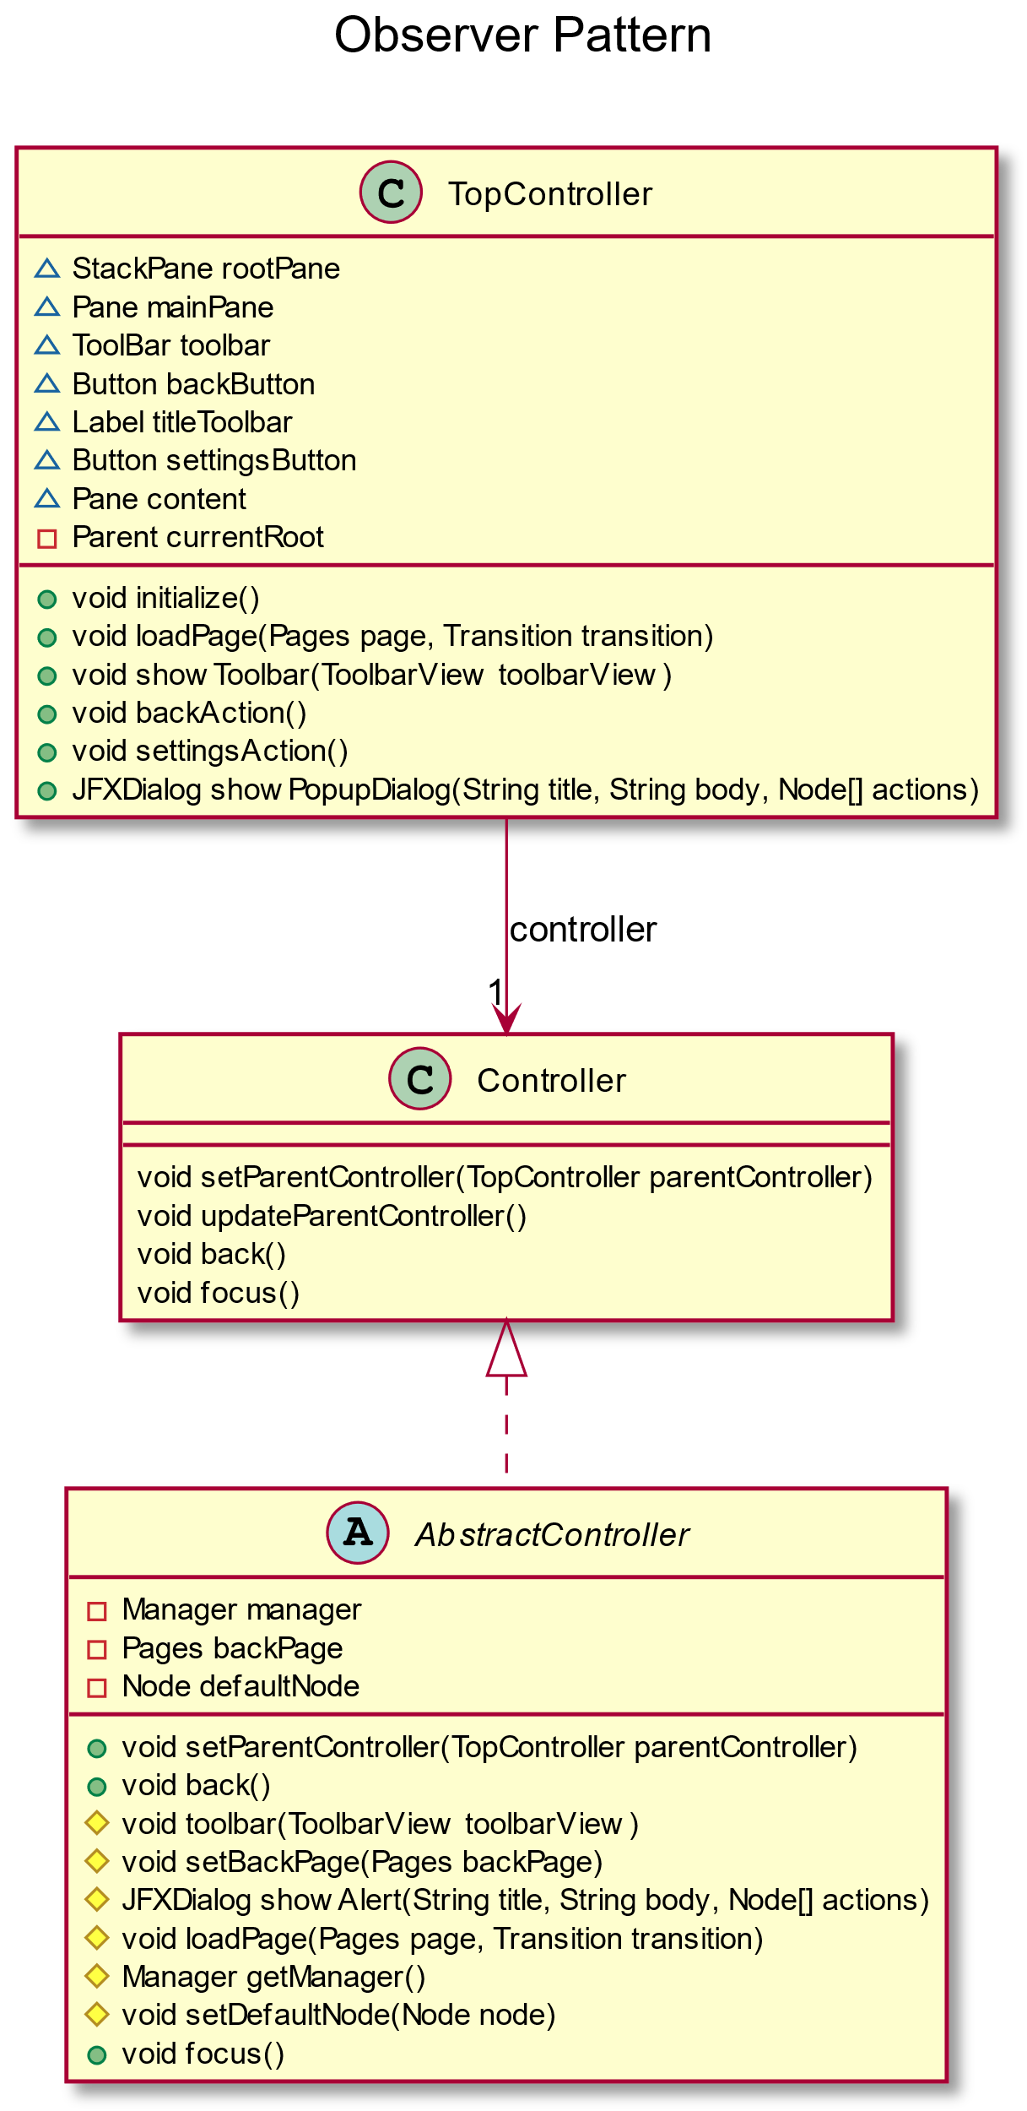

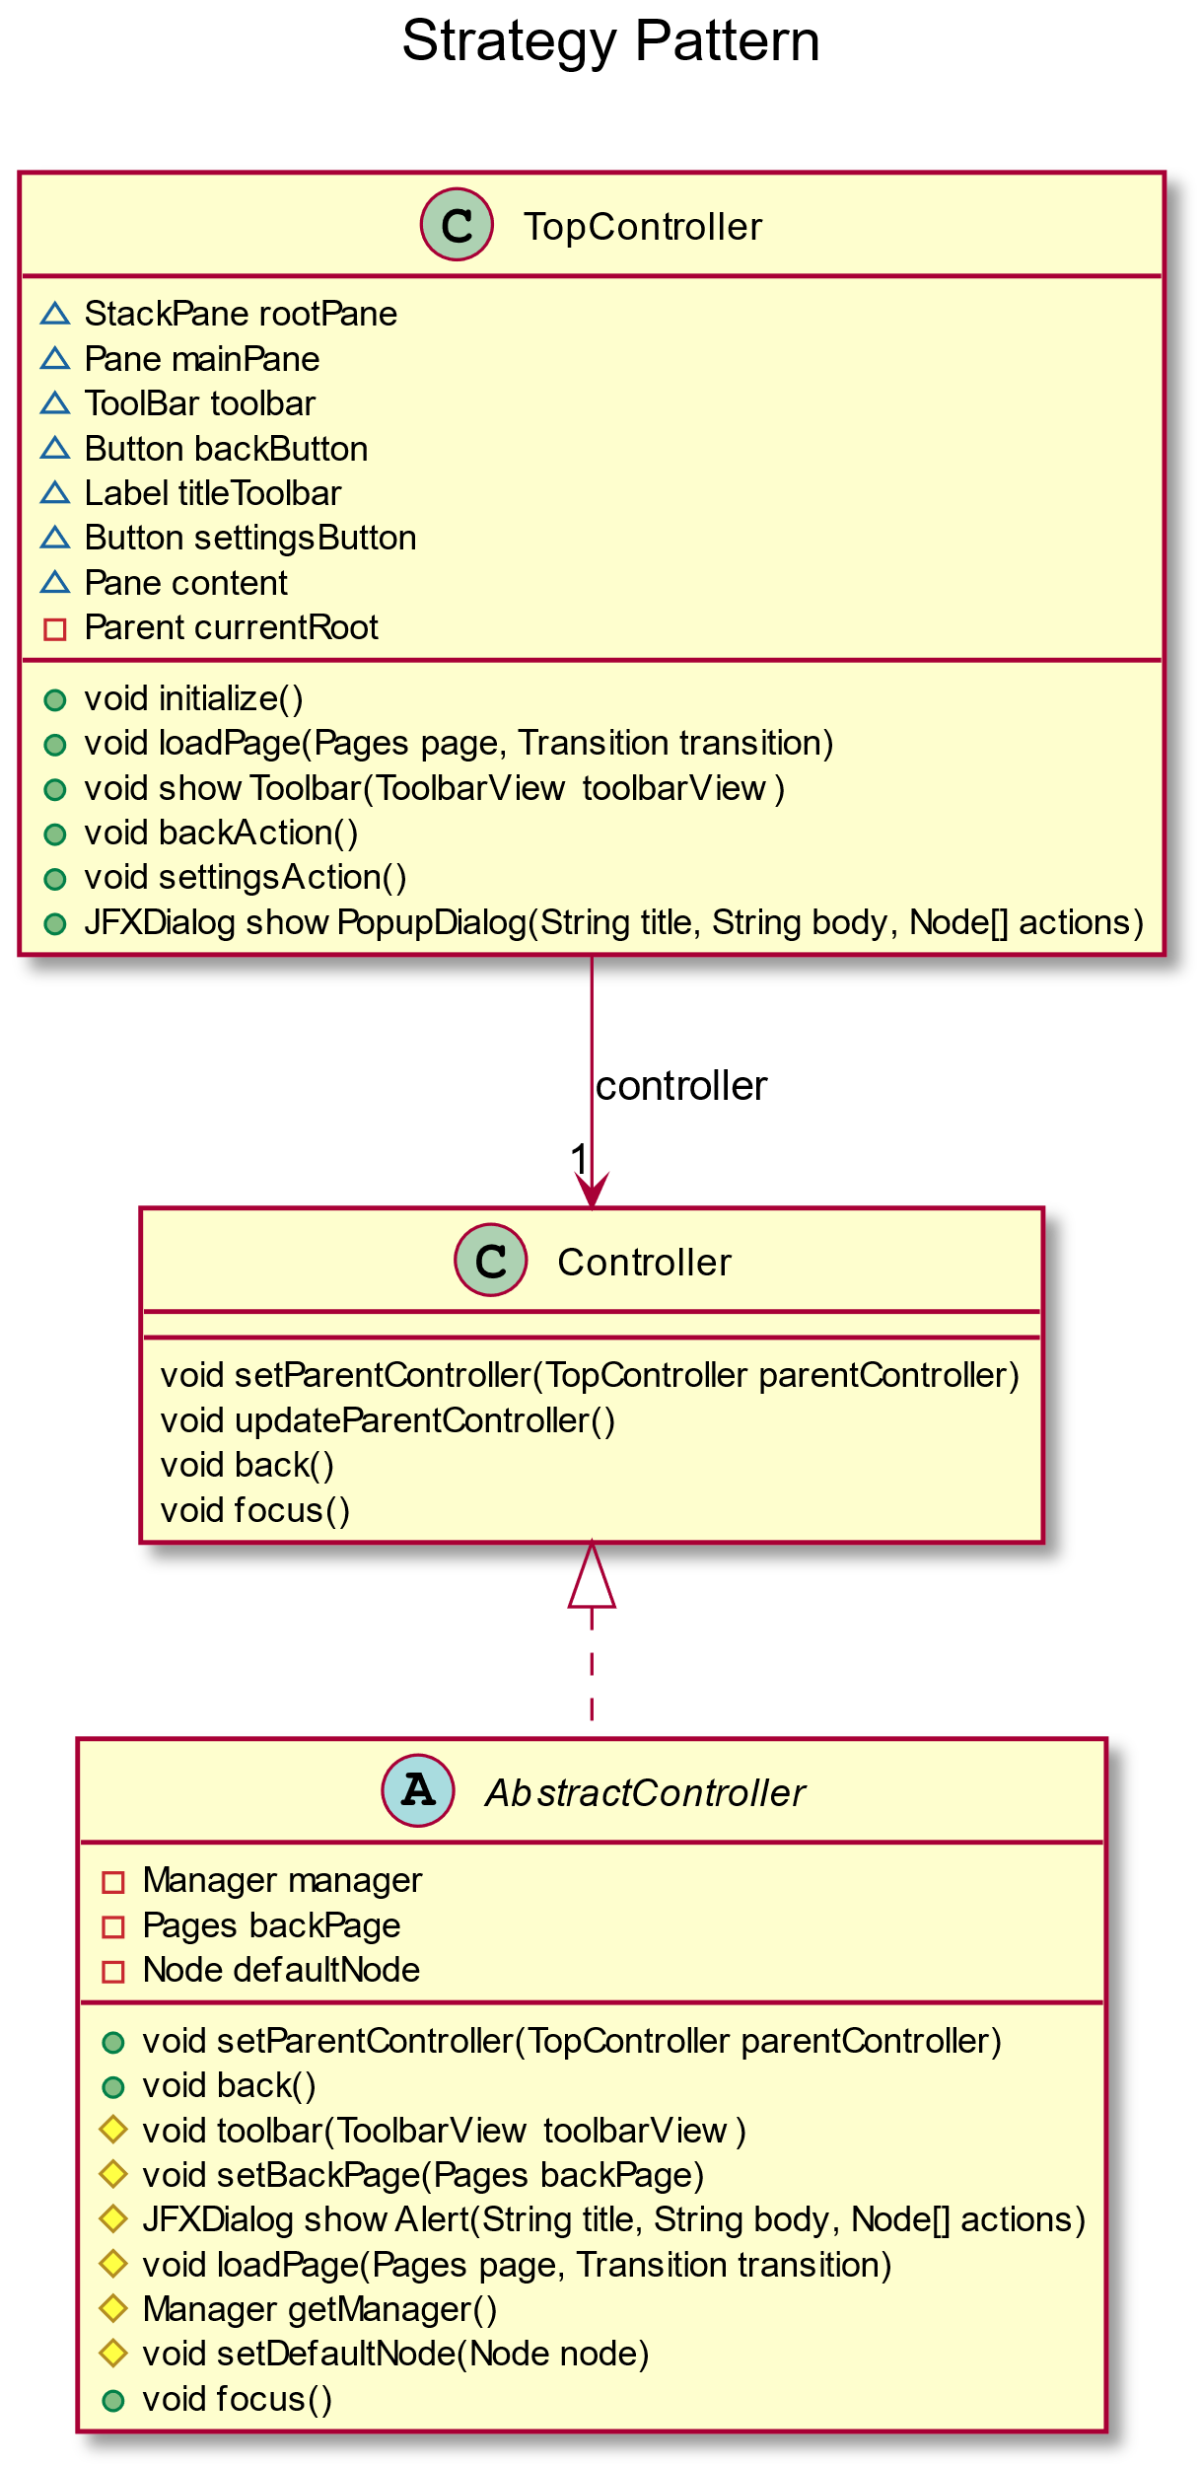

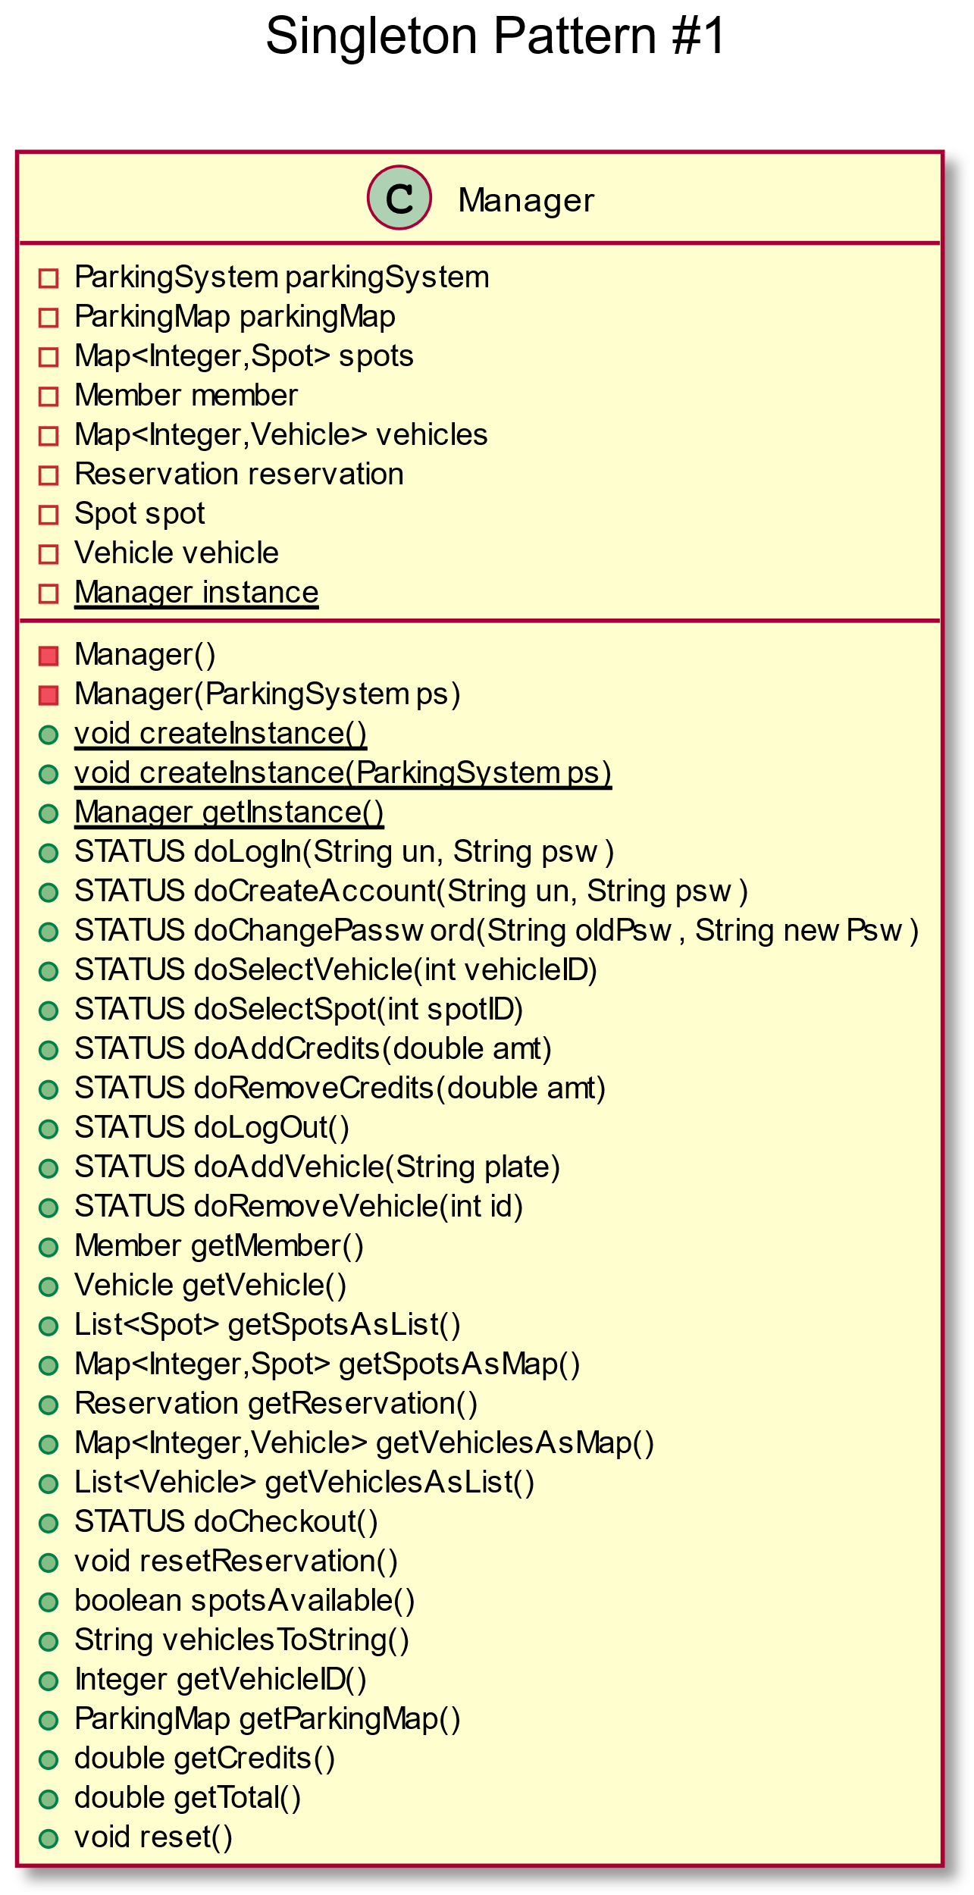

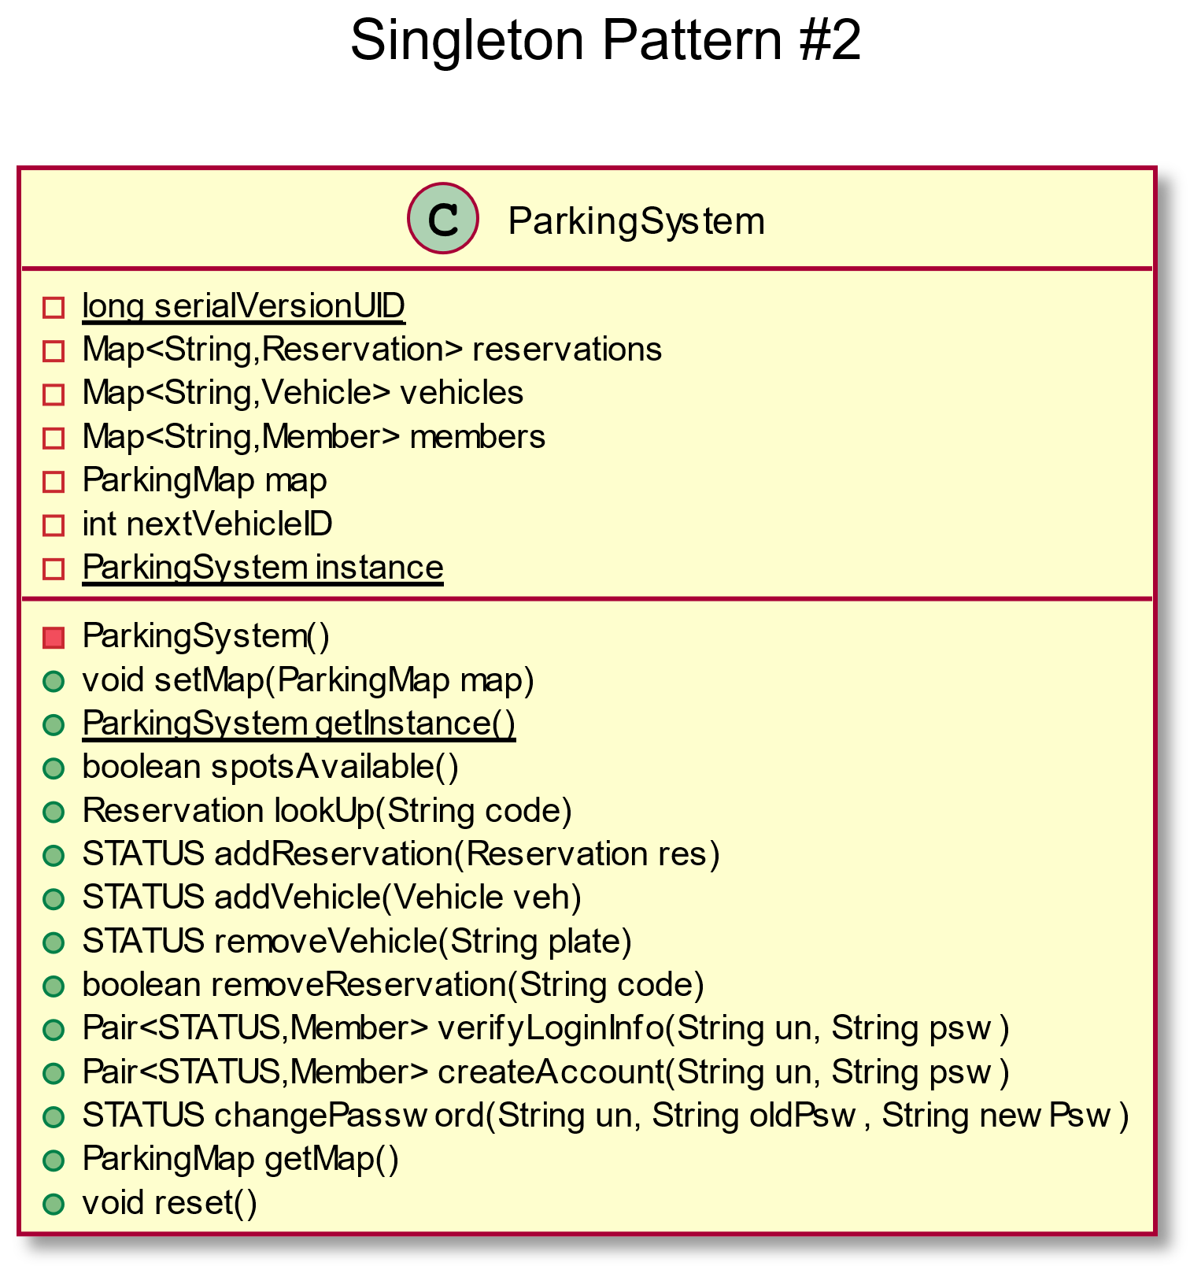

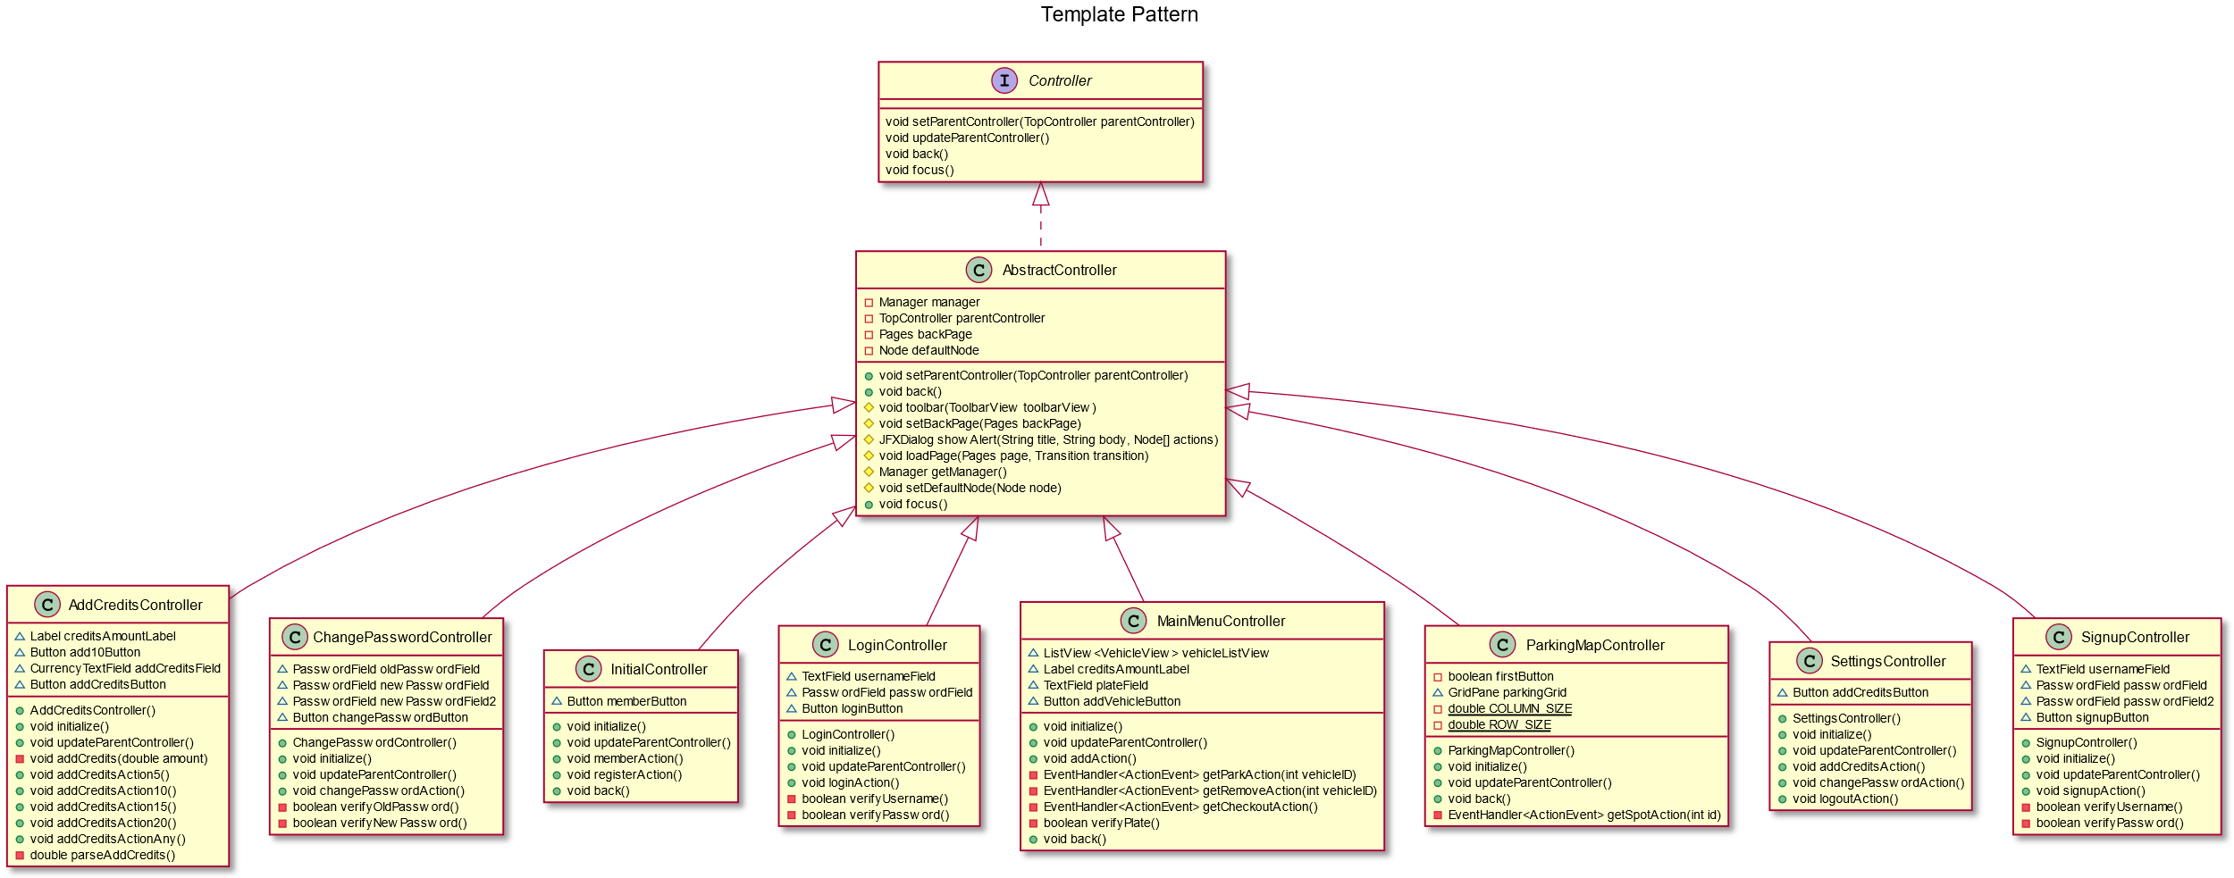

**What We Learned**

Working on our project this semester provided us with a lot of great hands-on experience. Collaborating on a project with multiple developers can be a challenge, but with the proper preparation and communication, it becomes very manageable. The two most valuable lessons we learned in terms of collaboration were the use of Git and efficient division of the work load. Using Git greatly facilitated collaboration by allowing us to work separately while having the ability to easily share changes with a simple “push” or “pull”. Additionally, by dividing the work in such a way that neither of us was ever working on the same file simultaneously, we mitigated the risk of conflicting changes which can quickly cause complications.

On the Object Oriented Design end, the main lesson we learned was the meaningful use of Design Patterns. The design patterns we used were Singleton, Façade, Adapter, Observer, Template, and Strategy, which were discussed in the Design Patterns section. By using them, we saved a lot of time that would have otherwise been spent “reinventing the wheel”.

Finally, we learned how to create a GUI application using MVC to tie together the model, view, and controller. Doing this correctly made it much easier to make changes to one aspect of the program without requiring changes elsewhere.

**Conclusion**

The project satisfied all the goals required for this project. A number of unit tests The design patterns used for the project were Singleton, Façade, Adapter, Observer, Template, and Strategy pattern. Some future work can be done in this project. Below is some of the ideas that can be done.

* + Add a guest that can park a vehicle without the need to log in.
  + Show parking is full and ask if customer wants to get notified when a spot becomes free. Also, allow the customer to reserve the spot some time ahead.
  + Customer with lost code pay the day pass rate for VIP.
  + Timed session. Members are automatically logged out when idle for a certain amount of time.

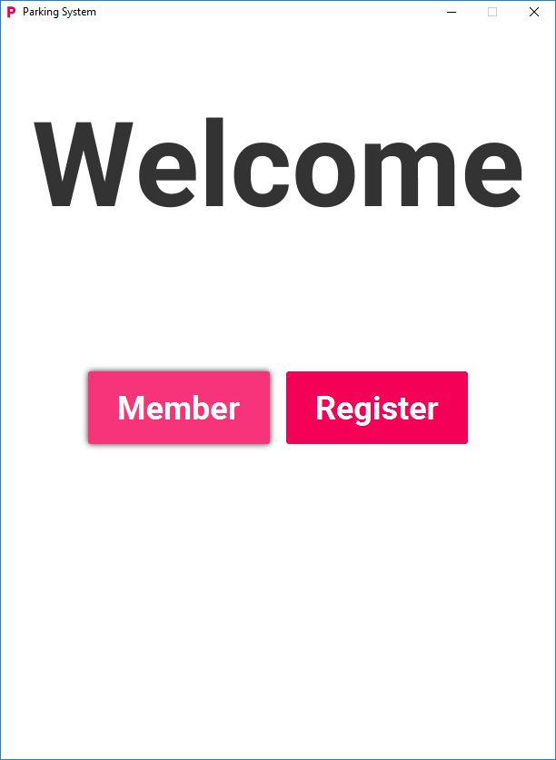 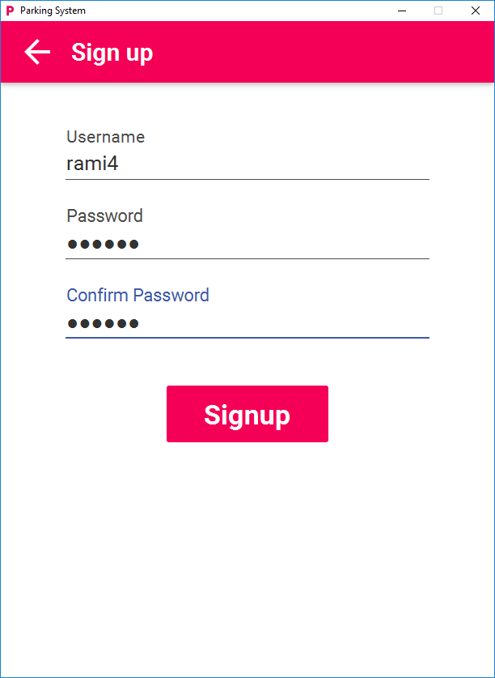 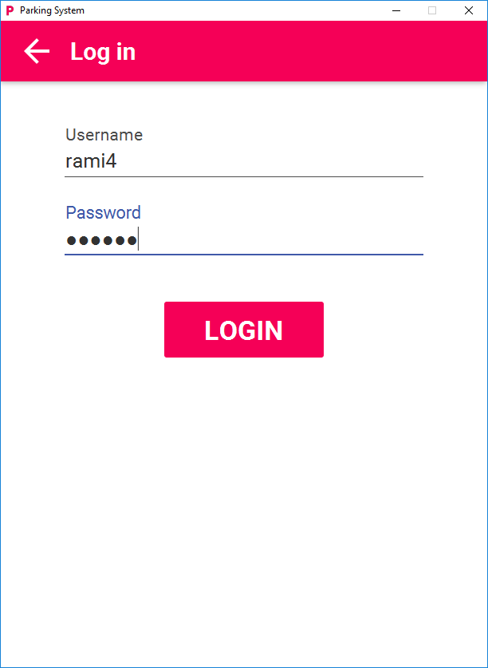 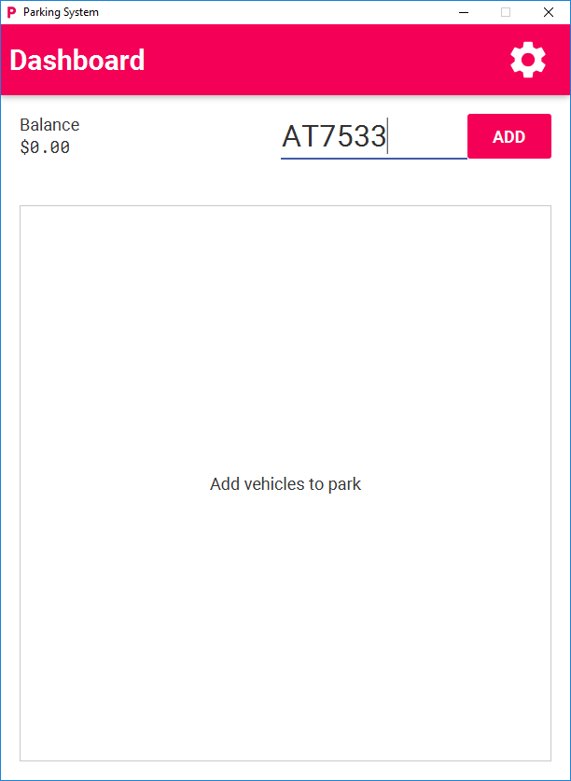 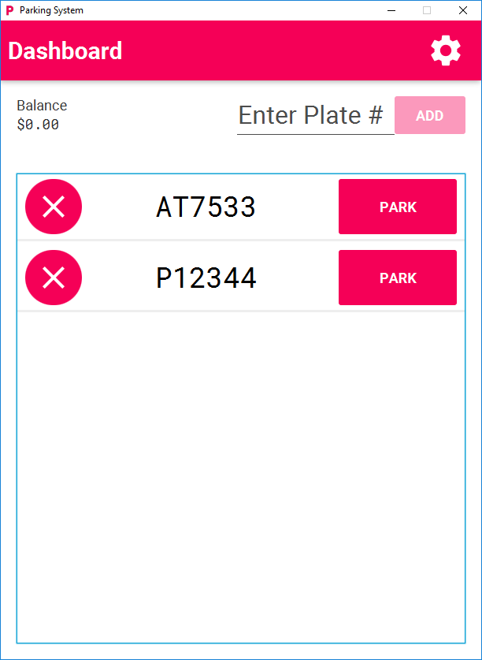

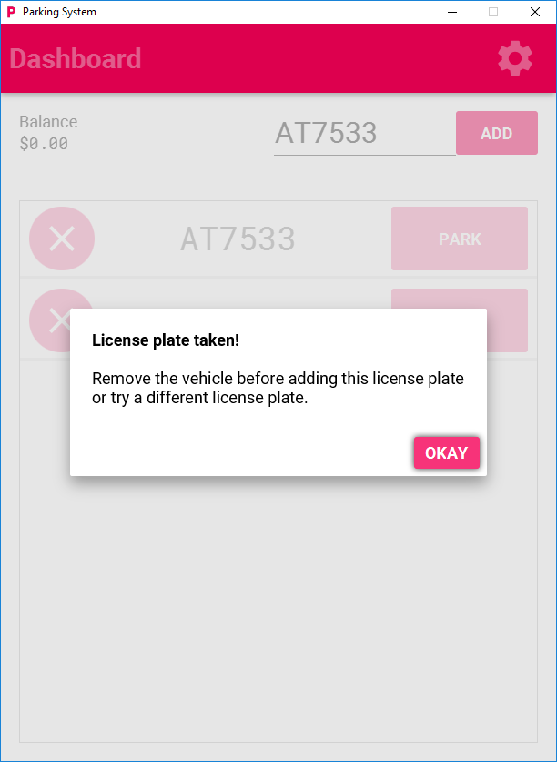 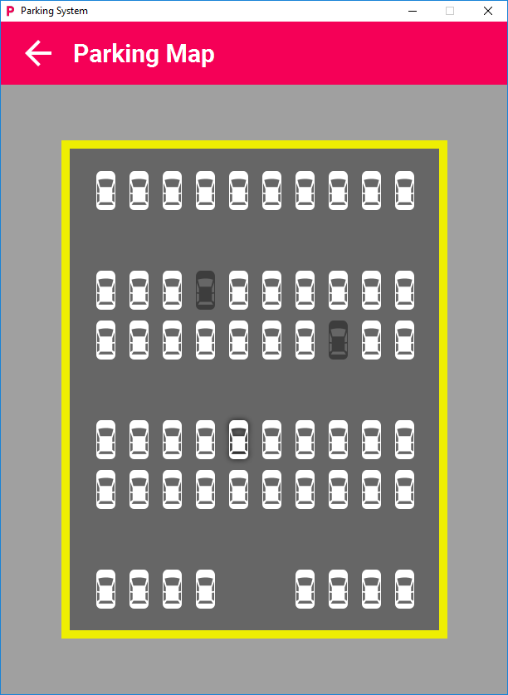 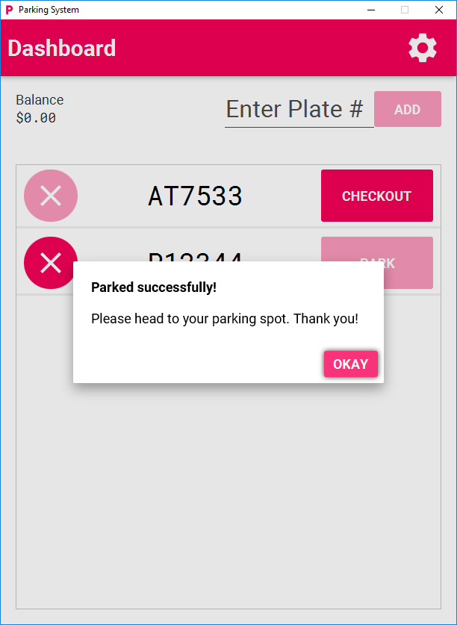 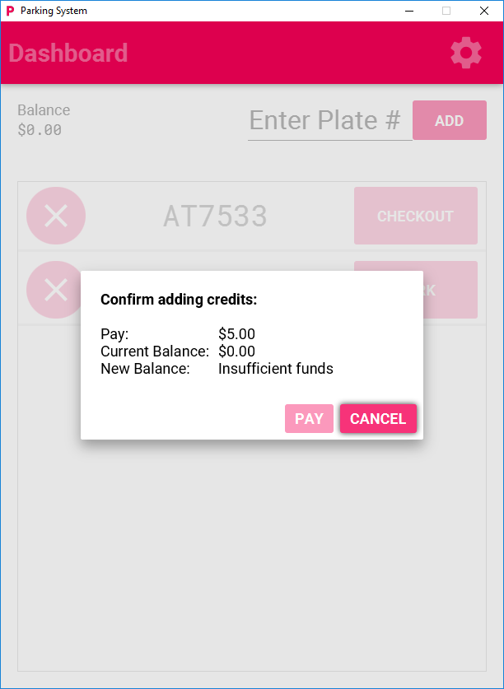 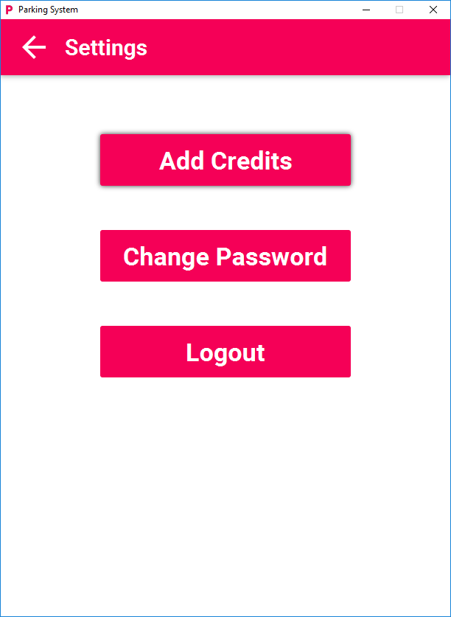 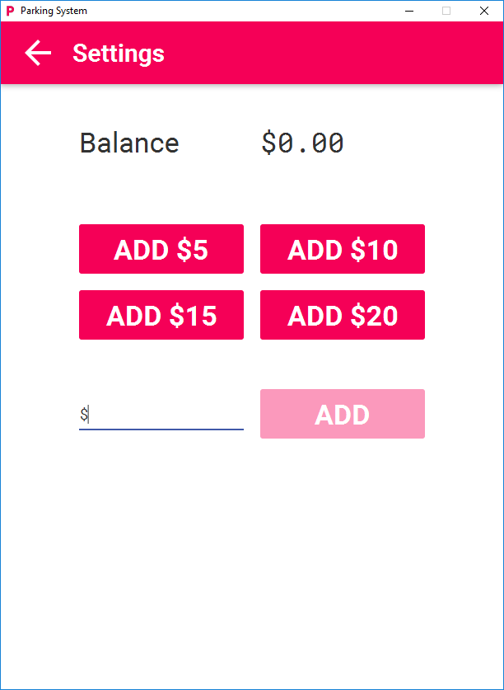 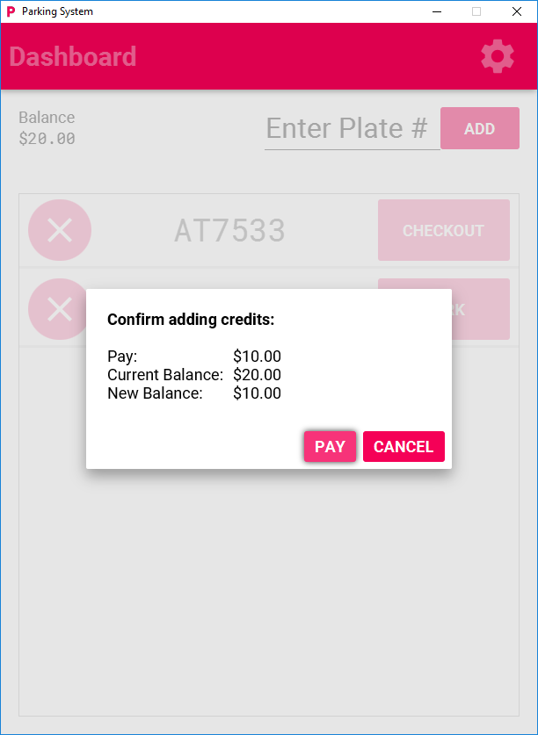 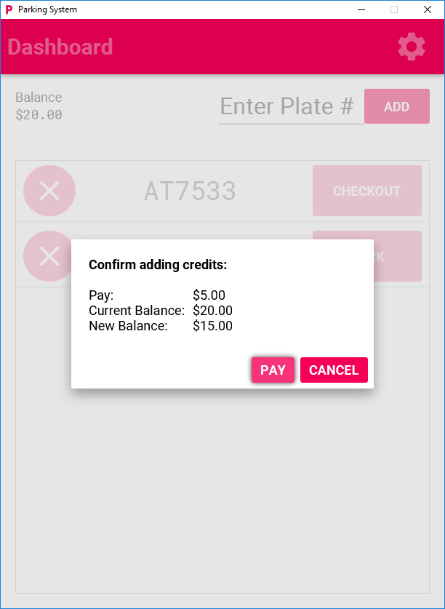 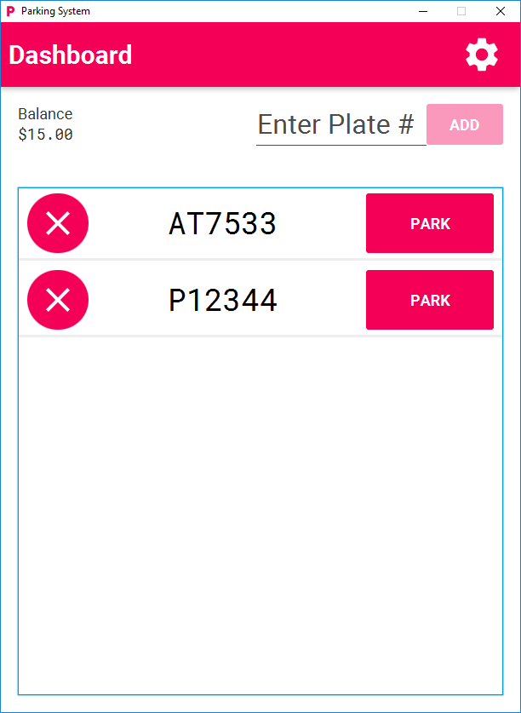 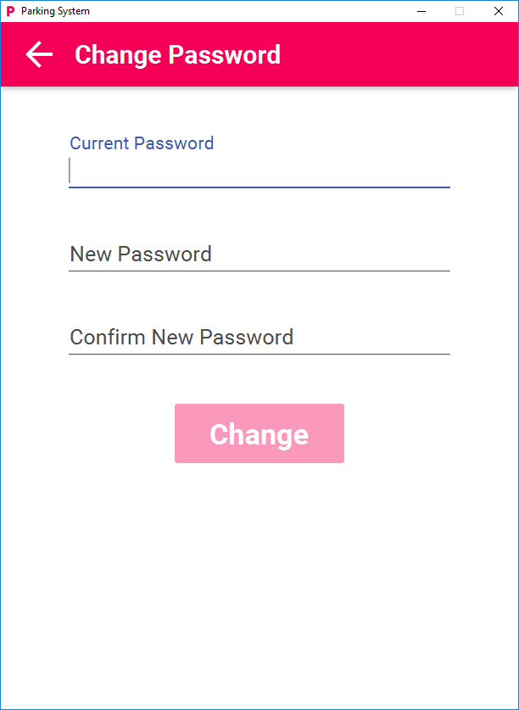

**Extra Screenshots**